TCP protocol acknowledgment thesis

2023

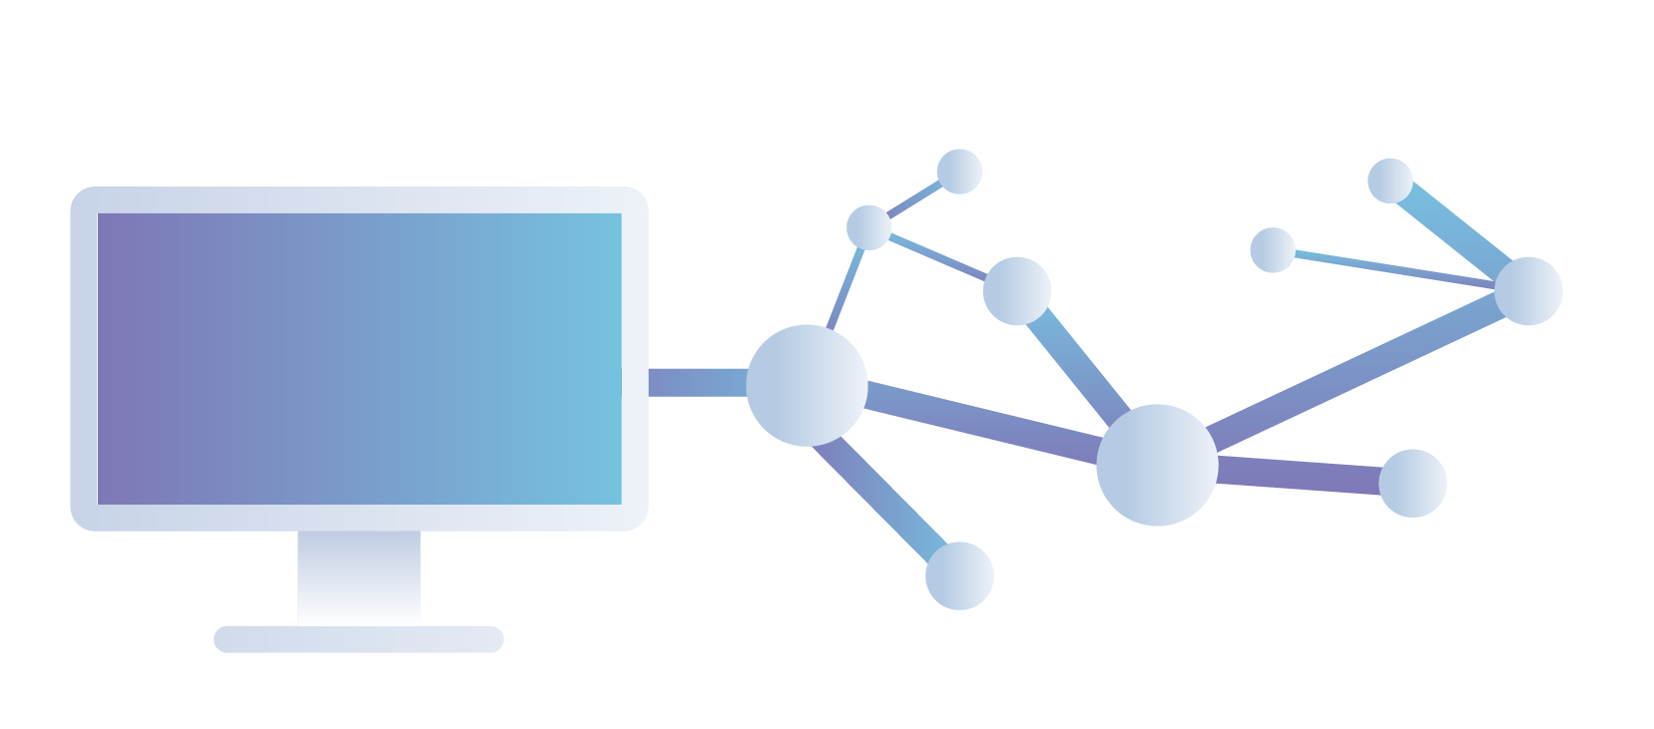

On the understanding that TCP packets in regular and Raspbian systems are delivered the same.

(Name)

**Abstract:**

How one may understand the use of TCP protocols being deployed in the world wide web. The reason they are used and how they function similarly in different operating systems. We have studied how different data layers, of computer networks, work. What are their respected functionalities and why they are used?

In detail, TCP protocols were studied and found how they function to improve packet transfer over the world wide web.

By using MacOS/Windows there is verification of different forms of TCP traffic and necessary throughput calculation to find out what has been the exact traffic speed of that TCP traffic

Raspberry Pi OS was then used to verify if the traffic functions in a similar way on a Raspbian-created web server and is able to transfer packet traffic in a similar way to standard OS systems.

**Table of contents:**

**Titles Page no**

**1. Thesis overview ---- 5**

**2. Data Networks ---- 7**

*2.1 Computer Networks*  **---- 8**

*2.2 TCP Network Architecture* **---- 9**

*2.3 Hybrid Model* **---- 10-16**

                 2.3.1 Physical Layer

                 2.3.2 Data Link layer

                 2.3.3 Network Layer

                 2.3.4 Transport Layer

                 2.3.5 Application Layer

1. **Network Packet Analyzers ---- 16**

*3.1 Wireshark*  **---- 17**

*3.2 tcpdump* **---- 17**

*3.3 Colasoft Capsa*  **---- 18**

**4. Server Creators and Authenticators ---- 19**

*4.1 Raspberry Pi*  **---- 20-22**

                 4.1.1 Installation

                 4.1.2 Server Creation

4.1.3 Client Creation

*4.2 Python* **---- 22-24**

                 4.2.1 Install

                 4.2.2 Environment Variables

                 4.2.3 Raspberry Pi server connection

1. **Wireshark  ---- 24-25**

*5.1 Installation process*

*5.2 Wireshark GUI*

**6. Global Server Implementation** **---- 26**

*6.1 Pre-requisites*   **---- 26**

*6.2 Implementation for packet capturing* **---- 27**

*6.3 Packet Analysis* **---- 28-38**

6.3.1 Identifying source port

6.3.2 TCP port and IP addresses from client trace

6.3.3 Syn connection to the server

6.3.4 SynACK sequence number verification

6.3.5 Sequence number

6.3.6 Sequence number estimated time

6.3.7 ACK of first 6 segments

6.3.8 Road time trip and Length of each segment

6.3.9 Minimal Reception window

6.3.10 Stevenson Graph time

**7. Raspberry Pi Custom Web-server Implementation ---- 38**

*7.1 Pre-requisites*  **---- 38**

*7.2 Loading Raspberry Pi OS*  **---- 39-40**

7.2.1 Writing Raspberry Pi OS on SD card

7.2.2 Connecting your Raspberry PI

*7.3 Basic Script Programming*  **---- 40-41**

7.3.1 Basic Web-server script

7.3.2 Wireshark installation

*7.4 Python Web-server Script Programming*  **---- 41-45**

*7.4.1 Python Web-server script*

*7.4.2* Client-side server programming

*7.5* Implementation for packet capturing **---- 46**

*7.6 Packet Analysis*  **---- 47-55**

7.6.1 Identifying Source port

7.6.2 *TCP port and IP addresses from client trace*

7.6.3 *Syn connection to the server*

7.6.4 *SynACK sequence number verification*

7.6.5 *Sequence number*

7.6.6 *ACK of first 6 segments*

7.6.7 *Road time trip and Length of each segment*

7.6.8 *Minimal Reception window*

7.6.9 *Stevenson Graph time*

**8. Conclusion ---- 55**

**9. References ---- 56**

***1. Thesis Overview:***

In this thesis, we will be proving whether a custom-created Raspberry Pi server can act the same as a global web server. In doing so we have seen how TCP traffic moves forward in both servers and have verified through that same TCP traffic whether or not both servers, function in the same way or not.

First, we have discussed details about data networks, the role of computer networks within the communication of different client servers, and how it has improved modern society. In doing so we have also described the hybrid model of data networks and its relevant layers that are included within the model.

Next, we have explained what network authenticators are, and what they are used for. They are technically used for capturing packet traffic or TCP traffic that is being communicated through a web server. In our case, we have used Wireshark to authenticate our implementation. We have also explained a small microchip used within the experiment called Raspberry Pi (formerly Raspbian) systems. Programming done within this chip is mainly through Python and Thony a Raspberry Pi built-in Python IDE. Python is an extensive development language that has been used to create and run our custom web server.

We have done two implementations to verify packet transfer protocols. First, we have used a standard operating system such as macOS/Windows to generate TCP traffic by connecting to the wife, running Wireshark, and opening relevant web pages. Then uploaded a text file to these web pages to monitor traffic sent between my machine and the web server. Then we created a Raspbian custom created server using Raspberry Pi with the help of Python.

We have used socket programming to perform two relevant functions, which are client server programming as well as web server programming. Once accomplished we have run the relevant web pages on the custom-created web server and uploaded the text file on those pages, to verify on Wireshark whether packet traffic is able to perform in a norm on our web server against a global server that we used in the prior implementation.

Through performing these actions, we have drawn the conclusion of the thesis at the end and added relevant referencing of papers that have been used within the said thesis. This was a short overview of the thesis further details are discussed as follows.

***2. Data Networks:***

Data networks are systems that allow for the transmission and exchange of digital information between devices. There are several different types of data networks, including local area networks (LANs), wide area networks (WANs), and wireless networks.

One of the most important components of a data network is the network protocol, which is a set of rules and standards that govern how devices communicate with each other. Some common network protocols include TCP/IP, which is used on the internet, and Ethernet, which is commonly used in LANs.

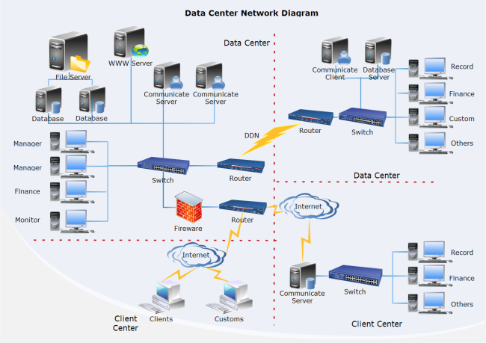

*Figure 1 A standard network created in data networks, this is how its architecture looks like*

Another important aspect of data network is security. As more and more sensitive information is transmitted over networks, it is crucial to have measures in place to protect that information from unauthorized access. Common security measures include firewalls, encryption, and secure login procedures.

Data networks also play a crucial role in the internet of things (IoT), where everyday objects are connected to the internet and can send and receive data. This allows for new possibilities such as smart homes, where appliances can be controlled remotely, and industrial internet, where machines can communicate with each other and make decisions based on data.

Overall, data networks are critical for the exchange of information in today's digital age and continue to evolve with new technologies to make them more efficient and secure.

***2.1 Computer Networks:***

Computer networks have become an essential part of our daily lives. The concept of a computer network has been around for decades, but the first commercial computer network was launched in 1969. Today, there are different types of computer networks. Each type is based on how many devices connect to one another and how those connections are managed. The most common form of computer network is a local area network (LAN), which connects devices within a limited area.

A wide area network (WAN) connects devices from different areas or countries. Computer networks provide us with tremendous opportunities, and they help shape our future. A computer network consists of multiple devices that connect to one another via a specific layer- for example, the transport or data link layer. Each device connected to a computer network is an endpoint- for example, a server, workstation, or terminal node- as well as an interface, which is the part of the device that connects to other devices. Multiple devices make up a node in a computer network.

These nodes are linked together by transceiver, bridge, and switch layers. The layers allow for the efficient transfer of information between nodes in the network. Multi-user computer networks require each user to have his own device called a node. Each node has its own configuration settings and allows multiple users access to the same computer network. These nodes communicate with each other using the data link and physical layer protocols. Each node on the network sends and receives data using its own set of resources such as RAM and hard drives.

This process is called communication and allows each user access to the files and resources he needs. Data is also protected during transmission using security measures such as encryption, decryption, and authentication protocols. Once data is collected on both ends, it's ready to be processed by the appropriate application on each node.

Each node must be assigned an address when setting up a computer network so that data can be transmitted to the correct node. Each device on the network must be given an IP address, and all connections between nodes must use this address scheme. This way, every connection between nodes uses the same IP address so data can be received properly by authorized nodes. Additionally, all nodes must have DHCP enabled so that their IP addresses can automatically update when needed.

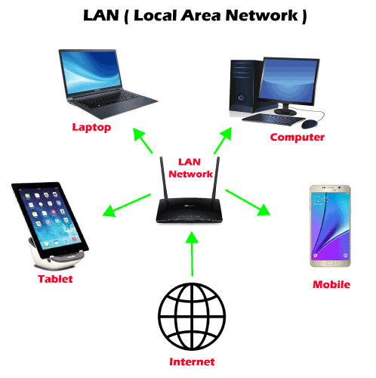

*Figure 2. 1 A local area network architecture, and how it would function.*

All this addressing makes it easy to configure your computer's connection to a LAN or WAN. Essentially, a computer network allows computers to communicate with each other via internet protocol (IP). Various layers allow for easy configuration and management of computer networks. In addition, multiple nodes make it easy to set up several devices for use in a multi-user environment. Computer networking has come a long way since its inception; today we rely on these powerful tools every day without thinking about it.

***2.2 TCP Architecture:***

TCP (Transmission Control Protocol) is a transport layer protocol that is used to establish a reliable connection between two devices in a computer network. It is responsible for ensuring that data is transmitted in a correct and orderly manner, and that any errors or lost packets are detected and retransmitted.

The TCP architecture is based on a client-server model, where one device (the client) initiates a connection to another device (the server) and requests to send data. The server then establishes a connection and begins to transmit data to the client.

TCP uses a series of mechanisms to ensure that data is transmitted reliably, including flow control and error checking. Flow control is used to ensure that the sender does not overwhelm the receiver with too much data, while error checking is used to detect and correct any errors that may occur during transmission.

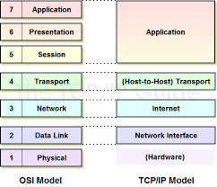

*Figure 2. 2 this shows the different level of layers present and functioning within the computer network system*

TCP also uses a process called "windowing" to improve the efficiency of data transmission. This process involves sending multiple packets of data at once, and then waiting for an acknowledgement from the receiver before sending the next set of packets.

The TCP architecture is designed to be flexible and adaptable, and it can be used with a wide range of different types of networks and applications. It is widely used on the Internet and is an integral part of many different types of online services and applications, including web browsing, email, and file transfer protocols.

***2.3 Hybrid Model:***

Hybrid models in data networks refer to the combination of two or more different types of models in order to improve the overall performance of the network. These models can be a combination of traditional models, such as rule-based systems and decision trees, with newer models, such as artificial neural networks and deep learning algorithms.

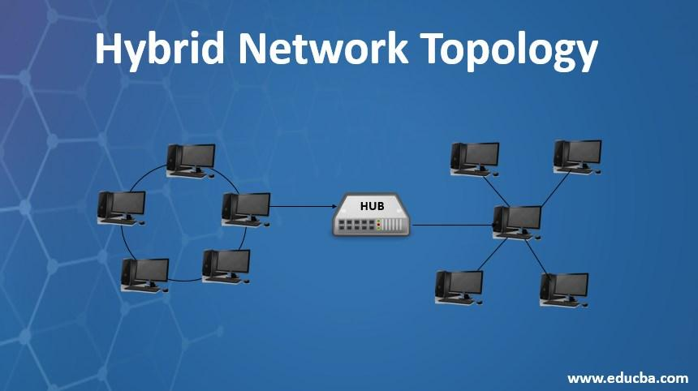

*Figure 2. 3 A standard hybrid model with circle and star topolgies*

One example of a hybrid model in data networks is the integration of a neural network with a decision tree. In this type of model, the neural network is used to process the raw data and identify key features, while the decision tree is used to make predictions based on those features. This combination allows for the neural network to identify complex patterns in the data, while the decision tree provides a clear and interpretable structure for making predictions.

Another example is the integration of a deep learning algorithm with a rule-based system. In this type of model, the deep learning algorithm is used to identify patterns in the data, while the rule-based system is used to make decisions based on those patterns. This combination allows the deep learning algorithm to identify complex patterns in the data, while the rule-based system provides a clear and interpretable structure for making decisions.

Hybrid models in data networks have been shown to have improved performance compared to traditional models, and can be useful for a variety of tasks such as image recognition, natural language processing, and predictive modeling.

In summary, Hybrid models in data networks are a combination of two or more different types of models in order to improve the overall performance of the network. These models can be a combination of traditional models, such as rule-based systems and decision trees, with newer models, such as artificial neural networks and deep learning algorithms. These models can be useful for a variety of tasks such as image recognition, natural language processing, and predictive modeling and have been shown to have improved performance compared to traditional models.

***2.3.1 Physical Layer:***

The Physical Layer is the first layer of the OSI (Open Systems Interconnection) model and is responsible for transmitting bits over a communication channel. It deals with the mechanical, electrical, and functional aspects of the interface between devices.

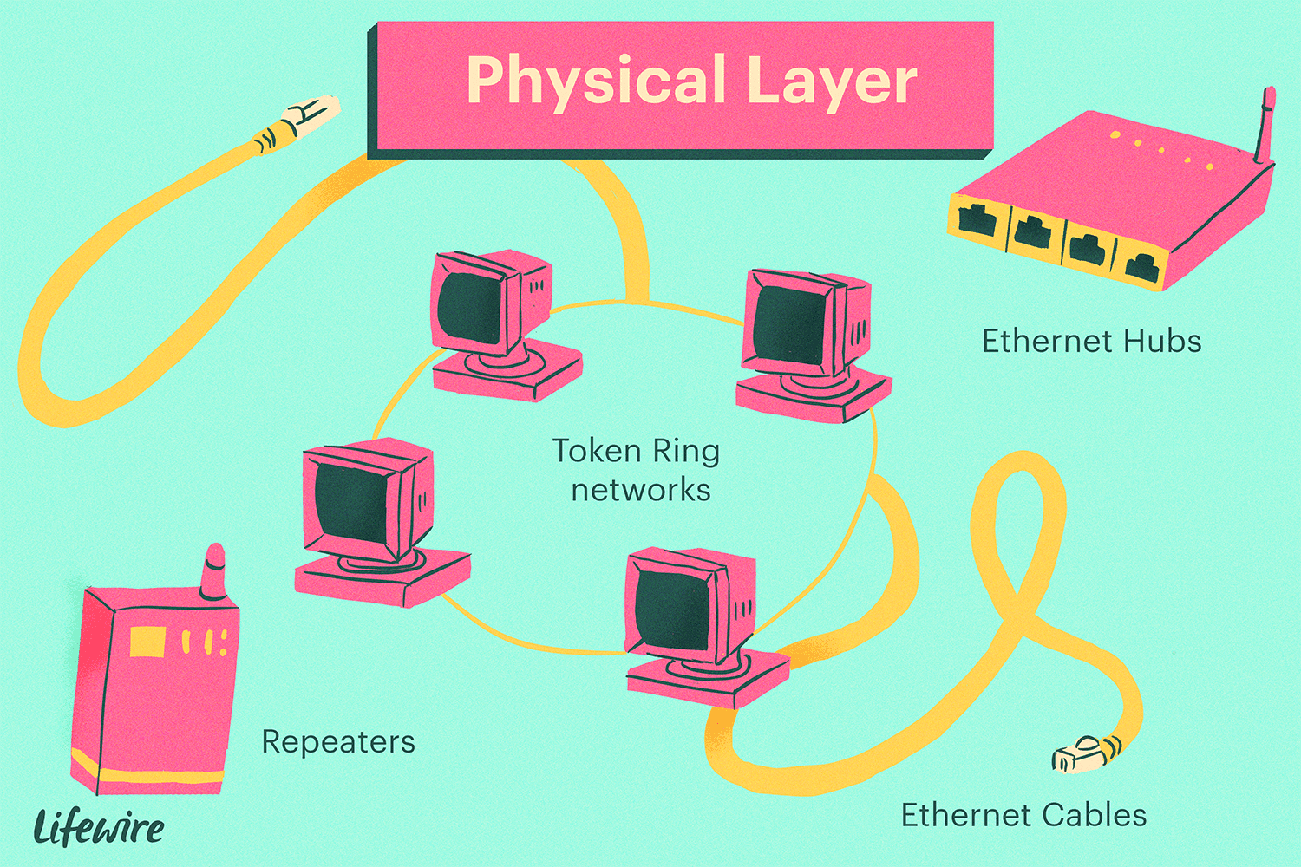

*Figure 2.3 1 Physical layers hardware that would be functioning and performing various tasks*

The Physical Layer is responsible for establishing, maintaining, and terminating physical connections between devices. This includes the use of connectors, cables, and other physical components to connect devices together. It also includes the definition of the electrical and optical signaling used to transmit data across the connection.

One of the key functions of the Physical Layer is to convert the digital data generated by the upper layers of the OSI model into a physical signal that can be transmitted over a communication channel. This signal is then received by the Physical Layer of the receiving device, where it is converted back into digital data that can be passed up to the higher layers of the OSI model.

The Physical Layer also includes specifications for the transmission of data over different types of communication media, such as twisted pair cable, coaxial cable, and optical fiber. Each type of media has its own unique characteristics and requires specific signaling and transmission techniques.

In addition to data transmission, the Physical Layer also includes specifications for device management and control. This includes the management of device power, as well as the control of device configuration and status.

Overall, the Physical Layer plays a critical role in the functioning of a computer network by enabling the physical connection and data transmission between devices.

***2.3.2 Data Link Layer:***

The data link layer is the second layer of the OSI (Open Systems Interconnection) model, and is responsible for providing a reliable link between network devices. It is responsible for physically delivering data across a network, as well as detecting and correcting errors that may occur during transmission.

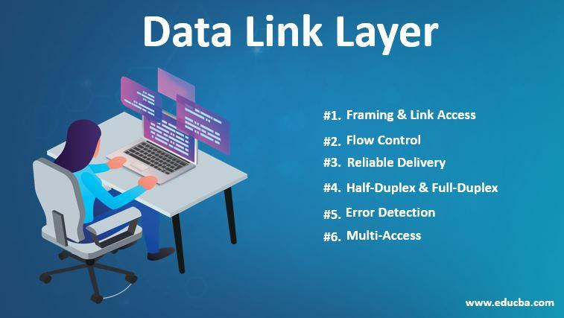

*Figure 2.3 2 Data link layer functions valued out in the image*

One of the key functions of the data link layer is error detection and correction. This is typically done through the use of checksums or cyclic redundancy checks (CRCs), which are mathematical algorithms that are used to detect errors in the data. If an error is detected, the data link layer will request that the data be retransmitted.

Another important function of the data link layer is flows control. This is used to prevent a sender from overwhelming a receiver with too much data at once. Flow control is typically implemented through the use of sliding window protocols, which allow the sender to send a certain number of packets before waiting for an acknowledgment from the receiver.

The data link layer is also responsible for addressing and routing data. Each device on a network is assigned a unique address, and the data link layer is responsible for ensuring that data is delivered to the correct destination. This is typically done through the use of media access control (MAC) addresses, which are unique identifiers assigned to each device on a network.

In summary, the data link layer is responsible for providing a reliable link between network devices by detecting and correcting errors in the data, managing the flow of data, and addressing and routing data to the correct destination.

***2.3.3 Network Layer:***

The network layer is the third layer of the OSI (Open Systems Interconnection) model, which is used to define the way that data is transmitted between different devices in a computer network. This layer is responsible for the routing and forwarding of data packets through a network, and it is the layer that enables data to be transmitted between different networks.

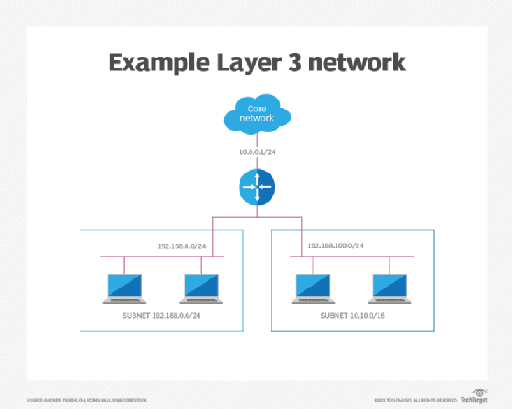

*Figure 2.3 3 Network layer example with IP addresses and subnet masks*

The main function of the network layer is to provide logical addressing, also known as IP addressing. Each device on the network is assigned a unique IP address, which is used to identify the device and to route data packets to their correct destination. The network layer also uses routing protocols to determine the best path for data to travel through the network, in order to reach its destination efficiently.

The network layer is also responsible for fragmentation and reassembly of data packets. This process is necessary when a packet is too large to be transmitted over a particular link, and it needs to be divided into smaller packets before being sent. Once the packets reach their destination, they are reassembled into their original form.

The network layer is also responsible for ensuring that packets are delivered in the correct order, and it also provides flow control to prevent network congestion. This layer also provide Quality of Service (QoS) to provide better service for time-sensitive applications like video conferencing, VoIP and other multimedia applications.

Some popular protocols used in the network layer are IP (Internet Protocol), IPv4, IPv6, ICMP (Internet Control Message Protocol) and IGMP (Internet Group Management Protocol). These protocols are widely used in various types of networks, from local area networks (LANs) to wide area networks (WANs) and the Internet.

***2.3.4 Transport Layer:***

The transport layer is the fourth layer of the OSI (Open Systems Interconnection) model, which is responsible for the end-to-end delivery of data between devices in a computer network. This layer is responsible for providing reliable and efficient communication between applications running on different devices.

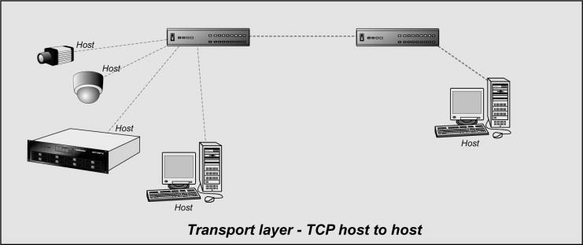

*Figure 2.3 4 Transport Layer Architecture with Host to Host example*

The main function of the transport layer is to provide a logical communication channel between applications running on different devices. It does this by breaking up data into smaller units called segments, and then transmitting them to the destination device. The transport layer also ensures that all of the segments are received correctly and in the correct order, and it can also provide flow control to prevent network congestion.

The transport layer is also responsible for providing error checking and correction, which helps to ensure that data is transmitted reliably. It also uses mechanisms such as flow control and congestion control to prevent the sender from overwhelming the receiver with too much data.

Two main protocols used in the transport layer are TCP (Transmission Control Protocol) and UDP (User Datagram Protocol). TCP is a connection-oriented protocol, which means that it establishes a virtual connection between two devices before transmitting data. It is reliable and provides error checking, retransmission and flow control. On the other hand, UDP is a connectionless protocol, meaning it doesn't establish a virtual connection before transmitting data, it's faster and efficient, but less reliable than TCP.

The transport layer is a critical component of any computer network, as it provides the means for applications to communicate with each other, regardless of the underlying network infrastructure. This layer is used in various types of networks, including local area networks (LANs), wide area networks (WANs), and the Internet.

***2.3.5 Application Layer:***

The application layer is the topmost layer of the OSI (Open Systems Interconnection) model, which is responsible for providing the interface between the network and the end user. This layer is responsible for providing the services and protocols that are needed by the applications and users to access the network.

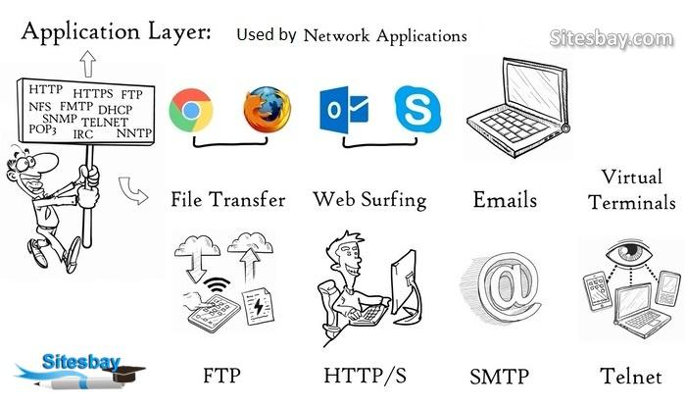

*Figure 2.3 5 Application layer where most things are accessed in their data form to physical form*

The main function of the application layer is to provide services and protocols that enable users and applications to access network resources and communicate with each other. It provides the means for users to interact with the network, such as through a web browser or email client. It also provides a variety of services such as file transfer, remote login, and virtual terminal access.

The application layer also defines the format and syntax of the data that is exchanged between applications. It provides the set of protocols and standards that are used by different applications to communicate with each other. Some of the most commonly used application layer protocols include HTTP (Hypertext Transfer Protocol), FTP (File Transfer Protocol), SMTP (Simple Mail Transfer Protocol), and DNS (Domain Name System).

This layer is also responsible for providing security for the application and data, by using protocols such as SSL/TLS for encryption and authentication, or using Firewalls to block unwanted traffic.

The application layer is crucial for enabling users to access and utilize network resources and services. It provides a wide range of services and protocols that are used by different types of applications, including web browsers, email clients, and file transfer programs. This layer plays a critical role in enabling communication and collaboration across networks, making it an important aspect of modern computer networks.

***3. Network Packet Analyzers:***

Packet analyzers, also known as packet sniffers or network analyzers, are tools used to capture and analyze network traffic. These tools allow network administrators and security professionals to monitor network activity, troubleshoot issues, and identify potential security threats. Packet analyzers can be hardware-based or software-based, and are available for a wide range of operating systems and platforms.

One of the key features of packet analyzers is their ability to capture and dissect network packets in real-time. This allows users to view detailed information about packets, including packet headers, payloads, and timestamps. Packet analyzers also provide a wide range of filtering and search options, allowing users to focus on specific packets of interest and ignore irrelevant data.

Packet analyzers also provide a wide range of advanced features for protocol analysis. They can decode and dissect a variety of network protocols, including TCP, UDP, HTTP, DNS, and many more. This allows users to understand the structure and content of packets, and troubleshoot issues such as network congestion, slow response times, and security breaches.

Packet analyzers can also be used for network security and forensics. They can detect and alert on potential network threats such as malware, worms, and other malicious activity. They also allow for the capture and analysis of wireless network traffic, including support for the latest wireless protocols and encryption methods.

Overall, packet analyzers are essential tools for network administrators and security professionals. They allow them to monitor network activity, troubleshoot issues and identify potential security threats. There is various packet analyzer software available like Wireshark, Colasoft Capsa, tcpdump, etc. Each of them has their own set of features and capabilities and selection of the right one depends on the specific needs of the organization.

***3.1 Wireshark:***

Wireshark is a free and open-source packet analyzer. It is used for network troubleshooting, analysis, software and communications protocol development, and education. Wireshark is cross-platform, using the GTK+ widget toolkit in current releases, and Qt in the development version, to implement its user interface, and using pcap to capture packets; it runs on Linux, macOS, BSD, Solaris, some other Unix-like operating systems, and Microsoft Windows.

Wireshark is able to read and dissect a variety of different network protocols, including TCP, UDP, HTTP, DNS, and many more. This allows users to analyze network traffic and troubleshoot issues such as network congestion, slow response times, and security breaches.

One of the key features of Wireshark is its ability to filter packets in real-time. This allows users to focus on specific packets of interest and ignore irrelevant data. Additionally, Wireshark provides a detailed view of packet data, including packet headers, payloads, and timestamps.

Another useful feature of Wireshark is its ability to export data in a variety of formats, including CSV, XML, and plain text. This allows users to easily share their analysis with others and integrate Wireshark data into other tools and systems.

Overall, Wireshark is a powerful and versatile tool that is widely used in the networking community. Its ability to capture and analyze network traffic in real-time, as well as its support for a wide variety of network protocols, make it an essential tool for network administrators and network engineers.

***3.2 Tcpdump:***

Tcpdump is a command line packet analyzer tool for UNIX and Linux operating systems. It allows users to capture and analyze network traffic in real-time, providing detailed information about packets including packet headers, payloads, and timestamps.

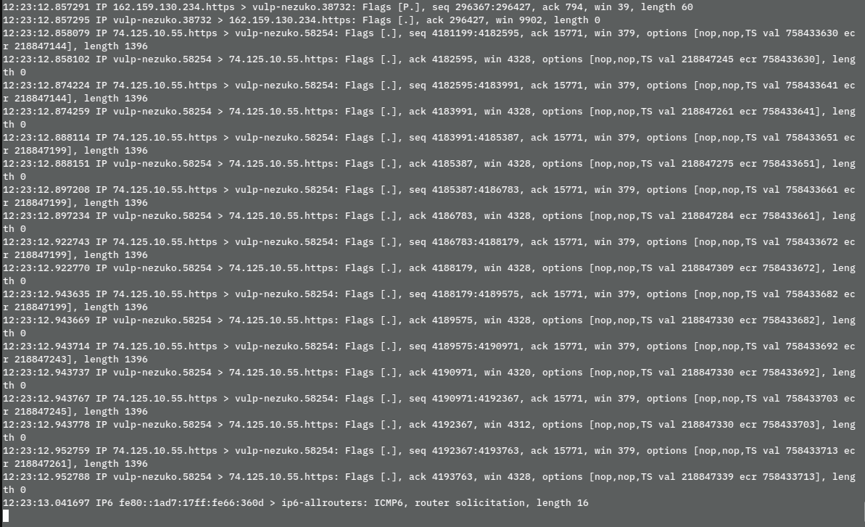

*Figure 3.2 1 tcpdump capturing packets with relevant IP addresses*

One of the key features of tcpdump is its ability to capture and filter packets using a wide range of criteria. Users can filter packets by source or destination IP address, port number, or protocol. This allows users to focus on specific packets of interest and ignore irrelevant data.

Tcpdump also provides a range of advanced features for protocol analysis. It can decode and dissect a wide variety of network protocols, including TCP, UDP, HTTP, DNS, and many more. This allows users to understand the structure and content of packets, and troubleshoot issues such as network congestion, slow response times, and security breaches.

Tcpdump can also be used to capture and save packets to a file, which can be later analyzed using other tools such as Wireshark. The output generated by tcpdump can be saved in a variety of formats, including libpcap, tcpdump, and pcapng.

Overall, tcpdump is a powerful and versatile command-line tool that is widely used in the networking community. Its ability to capture and filter packets in real-time, as well as its support for a wide variety of network protocols, make it an essential tool for network troubleshooting and analysis.

***3.3 Colasoft Capsa:***

Colasoft Capsa is a professional network analyzer software. It is used for network troubleshooting, protocol analysis, network monitoring, and network forensics. Capsa is available for Windows and macOS.

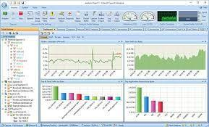

*Figure 3.2 2 Colasoft Capsa GUI*

One of the key features of Colasoft Capsa is its ability to capture and analyze network traffic in real-time. This allows users to monitor network activity and identify potential issues such as network congestion, slow response times, and security breaches. The software also provides a range of tools for analyzing network traffic including packet decoding, protocol analysis and expert diagnosis.

Capsa also offers a range of advanced features for network security and forensics. It can detect and alert on potential network threats such as malware, worms, and other malicious activity. The software also allows for the capture and analysis of wireless network traffic, including support for the latest wireless protocols and encryption methods.

Capsa also offers a range of export and reporting options, allowing users to easily share their analysis with others and integrate Capsa data into other tools and systems. Users can generate reports in a variety of formats, including PDF, Excel, HTML, and CSV.

Overall, Colasoft Capsa is a powerful network analyzer software that is widely used by network administrators and security professionals. Its ability to capture and analyze network traffic in real-time, as well as its support for a wide variety of network protocols and security features make it an essential tool for maintaining and securing networks.

***4. Server Creators and Authenticators:***

Web server creation tools are software programs that allow users to easily set up and manage web servers. These tools typically provide a user-friendly interface for configuring and managing web server software, such as Apache or Nginx, as well as for managing the underlying operating system and hardware.

One of the key features of web server creation tools is their ability to automate the process of setting up and configuring a web server. This can include tasks such as installing and configuring web server software, setting up virtual hosts, and managing security settings. This allows users to quickly and easily set up and manage web servers, even without a lot of technical expertise.

Another important feature of web server creation tool is their ability to manage and monitor web server performance. This can include monitoring server resource usage, tracking error logs, and managing backups. This allows users to identify potential issues, such as high traffic or slow response times, and take corrective action.

Web server creation tools also provide a range of tools for managing and securing web servers. This can include features such as SSL/TLS certificate management, firewall configuration, and password protection.

There are various web server creation tools available such as cPanel, Plesk, Webmin, etc. Each of them has their own set of features and capabilities and selection of the right one depends on the specific needs of the organization. Some are more suited for beginners and small-scale websites and others are more suited for large scale enterprise deployments. Overall, web server creation tools can be a valuable resource for anyone responsible for setting up and managing web servers, helping them to work more efficiently and effectively.

***4.1 Raspberry Pi:***

Raspberry Pi is a small, single-board computer that was first developed in the United Kingdom by the Raspberry Pi Foundation. It is designed to promote the teaching of basic computer science in schools and developing countries.

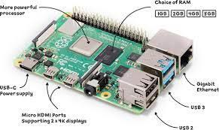

*Figure 4. 1 Raspberry Physical system and what its ports do*

The Raspberry Pi is available in several models, with the most recent being the Raspberry Pi 4. It features a quad-core 64-bit processor, 4GB of RAM, and supports dual-display output. Additionally, it has dual-band 802.11ac wireless, Bluetooth 5.0, BLE, Gigabit Ethernet, USB 3.0, and PoE capability (via a separate PoE HAT add-on).

One of the main advantages of the Raspberry Pi is its affordability. The basic model can be purchased for as little as $5, making it accessible to a wide range of users. Despite its low cost, the Raspberry Pi is capable of running a wide range of operating systems, including Linux and Windows 10 IoT Core.

The Raspberry Pi can be used for a wide range of projects, from simple projects like building a retro gaming console, to more advanced projects like building a home automation system or a media center.

Here are some of the most popular uses of Raspberry Pi:

* Media Center: Raspberry Pi can be used to build a media center to stream music, videos, and photos to your TV.
* Retro Gaming: The Raspberry Pi can emulate a wide range of classic game consoles, allowing you to play your favorite retro games on your TV.
* Robotics: The Raspberry Pi can be used to control robots, from simple line-following robots to more advanced robots that can navigate and avoid obstacles.
* Home Automation: Raspberry Pi can be used to control lights, thermostats, and other devices in your home, allowing you to create a smart home.

***4.1.1 Installation:***

Raspberry Pi is a small, low-cost computer that can be used for a variety of projects. Here is a step-by-step guide to installing the operating system on your Raspberry Pi:

1. Download the latest version of the Raspberry Pi operating system from the official website (<https://www.raspberrypi.org/downloads/>).
2. Insert a microSD card into your computer and format it using SD Formatter (<https://www.sdcard.org/downloads/formatter_4/>).
3. Download and install the Raspberry Pi Imager software from the official website (<https://www.raspberrypi.org/software/imager/>).
4. Open the Raspberry Pi Imager software and select the operating system image you downloaded earlier.
5. Select the microSD card you want to use for the installation.
6. Click on "Write" button to start the installation process.
7. Once the installation is complete, safely remove the microSD card from your computer and insert it into the Raspberry Pi.
8. Connect the power supply, keyboard, mouse and monitor to the Raspberry Pi and power it on.
9. Follow the on-screen instructions to complete the setup process.
10. Once the setup process is complete, you are ready to use your Raspberry Pi.

Note: It's important to follow the steps carefully and ensure that all the necessary components are connected to the Raspberry Pi before turning it on. It's also important to make sure that the correct version of the operating system is being installed for your specific model of Raspberry Pi.

***4.2 Python:***

Python is a high-level programming language that is widely used for web development, scientific computing, data analysis, artificial intelligence, and more. It is known for its simplicity, readability, and versatility, making it a popular choice among developers of all skill levels.

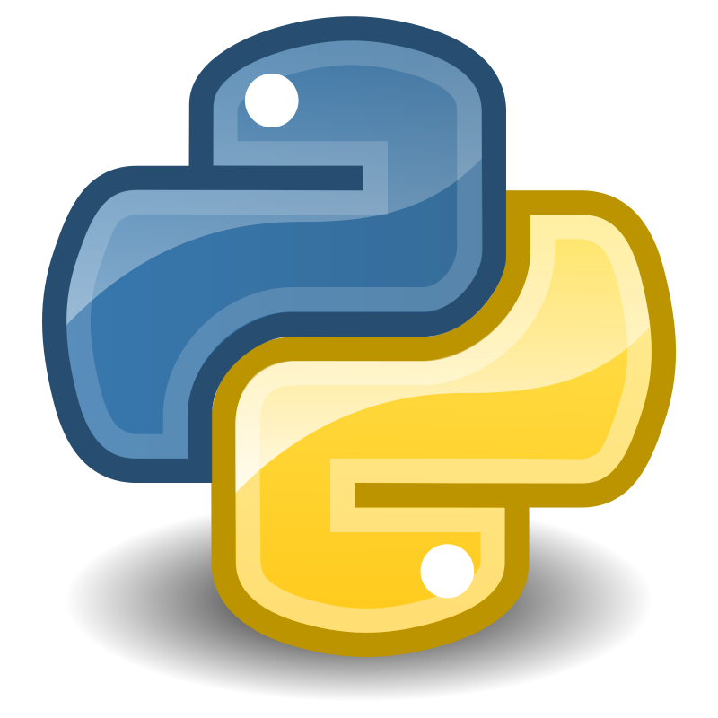

One of the key features of Python is its use of indentation to indicate code blocks, rather than curly braces or keywords like "begin" and "end." This makes the code more visually organized and easier to read.

Python also has a large and active community, with many libraries and frameworks available for use. Some popular ones include NumPy for scientific computing, Django for web development, and TensorFlow for machine learning.

Another advantage of using Python is its compatibility with other languages and platforms. Python code can be easily integrated with other languages such as C++ and Java, and can also be used on a variety of operating systems including Windows, MacOS, and Linux.

Overall, Python is a versatile and powerful programming language that is well-suited for a wide range of tasks and has a supportive community. It is a great choice for beginners and experienced programmers alike.

***4.2.1 Installation:***

Installing Python on a standard operating system:

1. Go to the official Python website (<https://www.python.org/>)
2. Download the latest version of Python for your operating system
3. Run the installer and follow the prompts to install Python on your computer
4. Verify the installation by opening a command prompt or terminal and running the command "python" to launch the Python interpreter

Installing Python on a Raspberry Pi:

1. Open the terminal on your Raspberry Pi
2. Run the command "sudo apt-get update" to update the package lists
3. Run the command "sudo apt-get install python3" to install Python 3
4. Verify the installation by running the command "python3" to launch the Python interpreter

Note: Depending on your specific use case, you may also want to install pip (Python package installer) on your system by running the command "sudo apt-get install python3-pip" on Raspberry Pi and "python get-pip.py" on a standard operating system.

***4.2.2 Environmental variables:***

Python environment variables are a way to configure the behavior of Python and the libraries it uses. They can be used to change the location of certain files, specify the version of Python to use, and configure other settings.

One common use of environment variables is to specify the location of Python packages. The PYTHONPATH environment variable can be set to a list of directories separated by colons, and Python will search these directories for modules to import.

Another useful environment variable is PYTHONHOME. This variable can be used to specify the location of the Python installation, which can be useful when you have multiple versions of Python installed on your system.

To set an environment variable in Windows, you can use the setx command in the command prompt. For example:

**Method 1:**

setx PYTHONPATH "C:\python\lib;C:\python\lib\site-packages" .

On Linux and macOS, you can use the export command in the terminal. For example:

export

PYTHONPATH="/usr/local/lib/python3.8:/usr/local/lib/python3.8/site-packages"

**Method 2:**

It is also possible to set environment variables temporarily by using the command **os.environ** .

import os

os.environ['PYTHONPATH'] =

'/usr/local/lib/python3.8:/usr/local/lib/python3.8/site-packages'

It is important to note that the changes made to environment variables using the above methods will only be valid for the current session or terminal window. To make the changes persist across reboots or new terminal sessions, you'll need to add the export or setx command to your shell startup file (e.g., .bashrc or .bash_profile).

In summary, Python environment variables can be used to configure various aspects of Python's behavior and the behavior of the libraries it uses. These variables can be set using the setx and export commands on Windows and Linux/macOS respectively, and can be accessed using the os.environ module in python.

***4.2.3 Python Flask:***

we will be using Python flask to create and validate our web server, a brief introduction about flask is as follows:

***5. Wireshark:***

A over view of Wireshark is given in section 3.1 of the thesis, here I have explained its installation process and interface.

***5.1 Installation:***

Wireshark is a popular network protocol analyzer tool that can be used on Windows and Raspberry Pi operating systems. Here is a step-by-step guide on how to install Wireshark on both platforms:

For Windows:

1. Download the Wireshark installer from the official website (<https://www.wireshark.org/>)
2. Run the installer and follow the prompts to install Wireshark.
3. Once the installation is complete, open the program from the Start menu or by searching for it in the Windows search bar.

For Raspberry Pi:

1. Open the terminal and update the package list by running the command "sudo apt-get update"
2. Install Wireshark by running the command "sudo apt-get install wireshark"
3. Once the installation is complete, open Wireshark by running the command "wireshark" in the terminal.

Note: On Raspberry Pi, wireshark needs to be run as superuser, otherwise it will give error.

Please keep in mind that capturing packets on a Raspberry Pi may be limited due to its hardware capabilities, so it may not be suitable for high-speed or high-bandwidth networks.

Also, in some cases, Wireshark may not be able to capture packets on Windows or Raspberry Pi due to user permissions. In such cases, you may need to run Wireshark as an administrator or with elevated privileges.

***5.2 Wireshark GUI:***

This is how Wireshark GUI would look like when you are done with its installation,

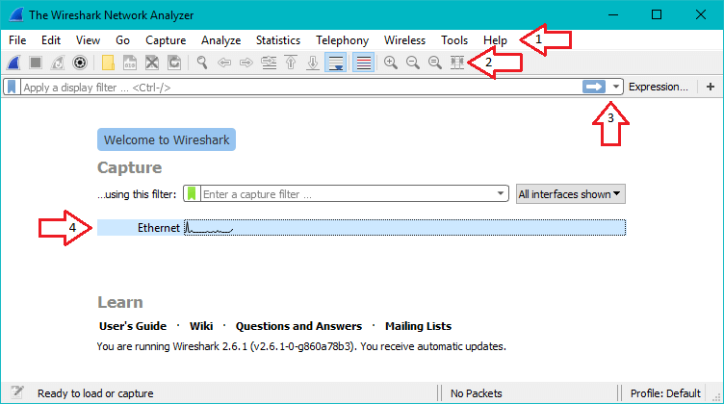

*Figure 5. 1 Wireshark GUI and its different parts*

Packet capturing on Wireshark would look something like this,

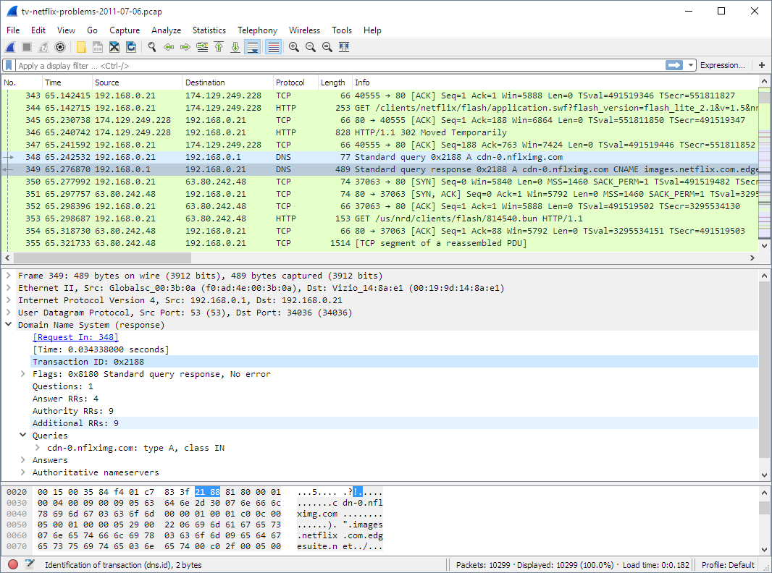

*Figure 5. 2 Wireshark Packet Capture*

***6. Global Server Implementation:***

In this part of the document we shall implement packet analyzing and traffic capturing of global server. We will be implementing packet capturing by using specific web pages and pulling them into global server using a simple browser, such as Chrome. Then we shall analyze these packets draw similarities in the custom server implementation.

***6.1 Pre-requisites:***

This implementation requires a certain number of pre-requisites which are listen as follows:

**Hardware requirements:**

* Personal Computer/Laptop
* Mouse
* Keyboard
* Screen in case of Personal Computer

**Virtual requirements:**

* Internet connection
* Internet browser (Firefox, Chrome, Opera, Explorer etc)
* Wireshark
* Relevant Web pages and file.

***6.2 Implementation for packet capturing:***

1. Open your browser and retrieve a copy of alice.txt from <http://gaia.cs.umass.edu/wiresharklabs/alice.txt>
2. Now load the following link to upload alice.txt: <http://gaia.cs.umass.edu/wireshark-labs/TCP-wireshark-file1.html>

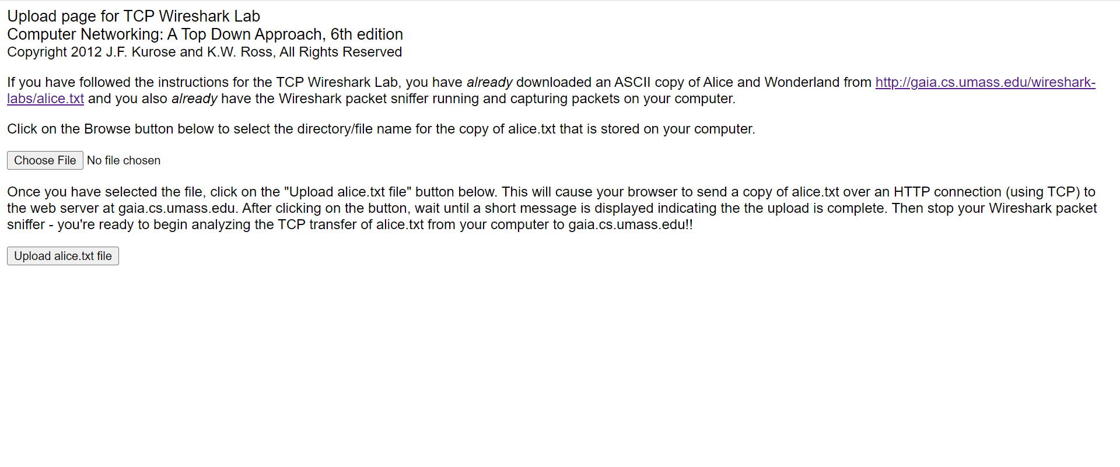

*Figure 6.2 1 Gaia.cs web page*

1. Use the browse button on the form to locate and select the file containing "Alice in Wonderland" on your computer. Do not press the "Upload alice.txt file" button yet.

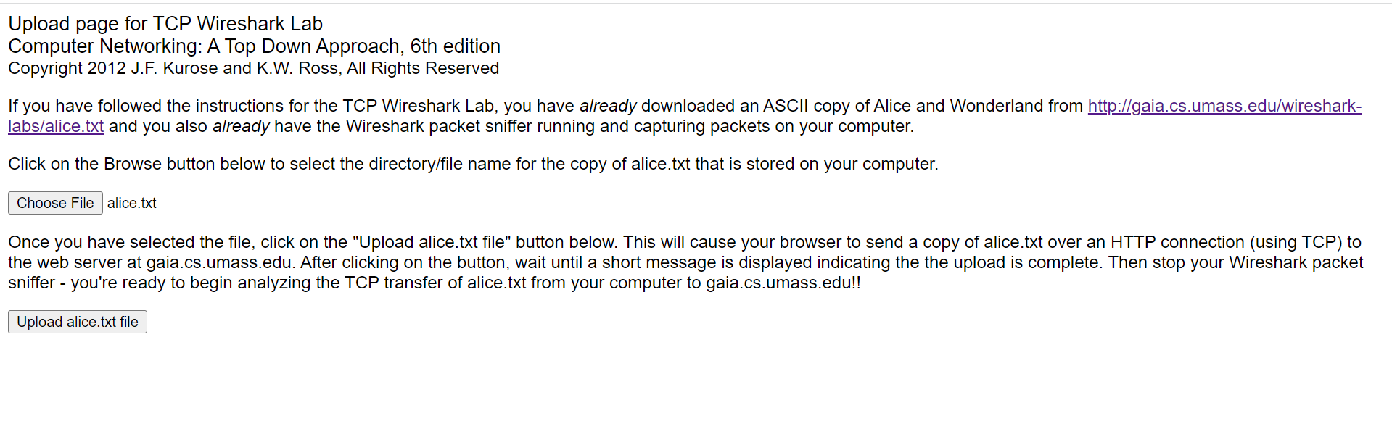

*Figure 6.2 2 Alice.txt ascci upload to Gaia.cs Web page*

1. Open Wireshark and start packet capture by going to Capture > Options, then press OK on the Wireshark Packet Capture Options screen.
2. In your browser, press the "Upload alice.txt file" button to upload the file to the gaia.cs.umass.edu server. A message will appear in your browser window once the file has been successfully uploaded.
3. Stop the Wireshark packet capture.

The Screen should look like this,

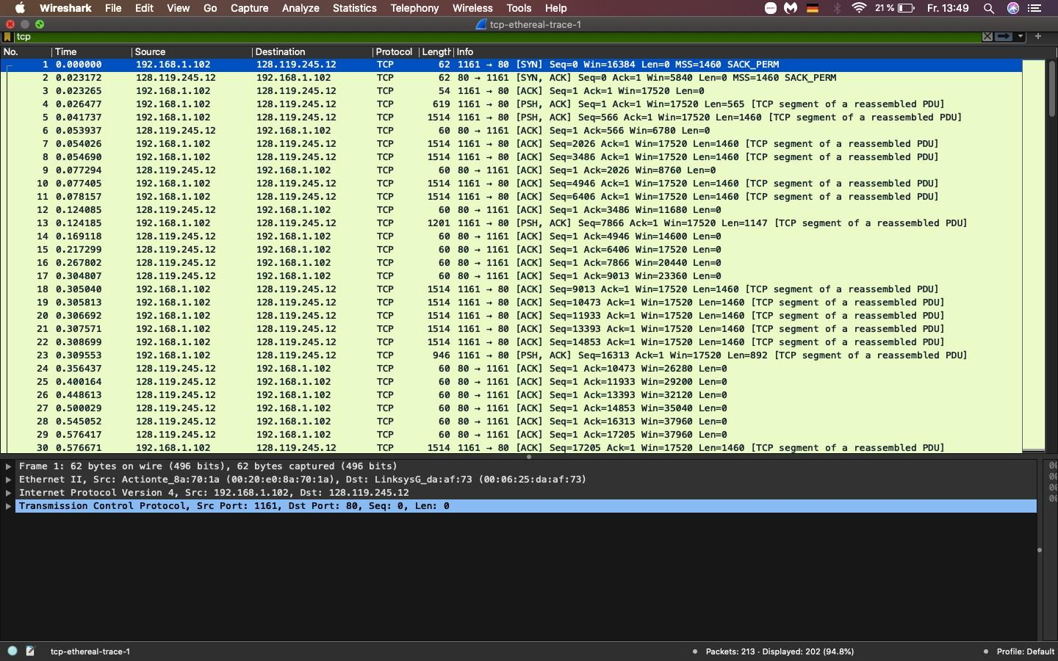

Now we analyze these packets.

***6.3 Packet Analysis:***

Packet Analysis of this implementation is given as follows:

***6.3.1 Identifying Source port:***

The IP address and TCP port number used by the client computer(source).

IP address: 192.168.1.102 TCP port number: 1161

The IP address and TCP port number used by gaia.cs.umass.edu

IP address: 128.119.245.12 TCP port number: 80

The IP address and TCP port number from my own client-computer(source)to gaia.cs.umass.edu.

IP address: 10.1.14.94 TCP port number: 51800



In this the grey highlighted text shows the source port from where the packet was sent.

***6.3.2 TCP port and IP addresses from client trace:***

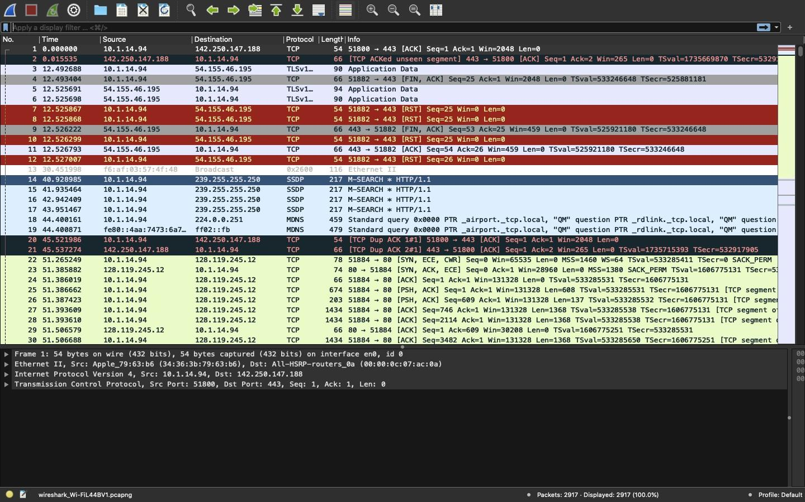

*Figure 6.3 2 TCP port and IP address from client computer*

This figure shows us TCP port numbers as well as IP addresses that are being issued or communicated from our own trace.

***6.3.3 Syn connection to the server:***

The sequence number of the TCP SYN segment used to establish a TCP connection between the client computer(source) and gaia.cs.umass.edu is 0. In order for the SYN segment to be identified, SYN=1

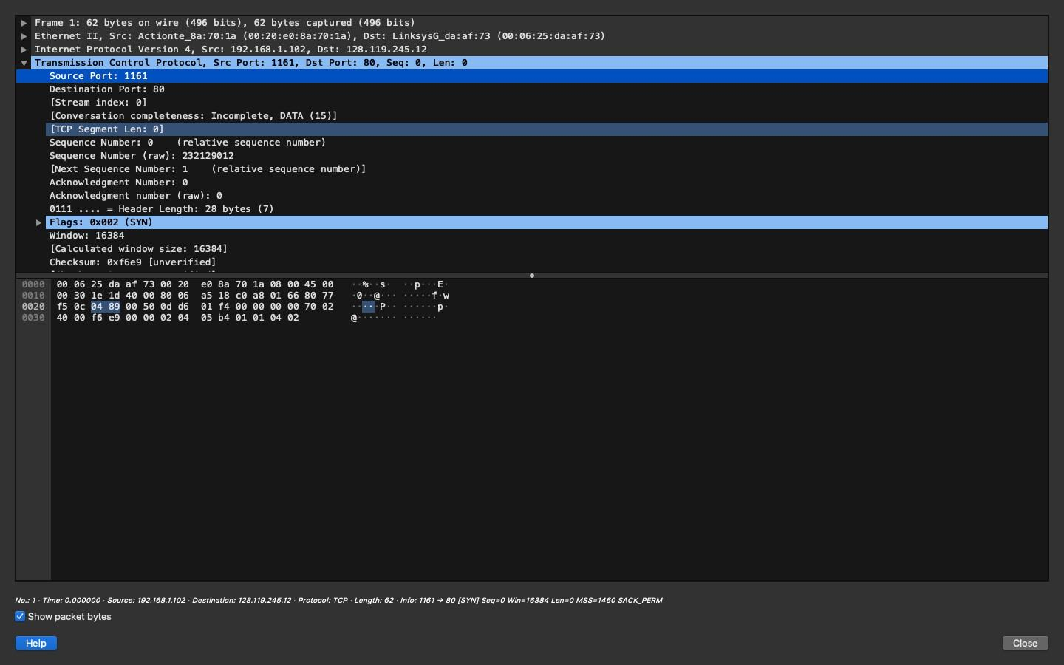

***6.3.4 SynACK sequence number verification:***

The sequence number of the SYNACK segment returned from gaia.cs.umass.edu

on the client computer the value is 0. The value of the confirmation field in the SYNACK segment is 1. To determine this value, 1 is added to the initial value of the sequence number. and in our case the sequence number is =0. to identify that a segment is a SYNACK segment, the SYN index and the ACK index in the segment are set to 1 law, and indicate that this segment is a SYNACK segment.

***6.3.5 Sequence number:***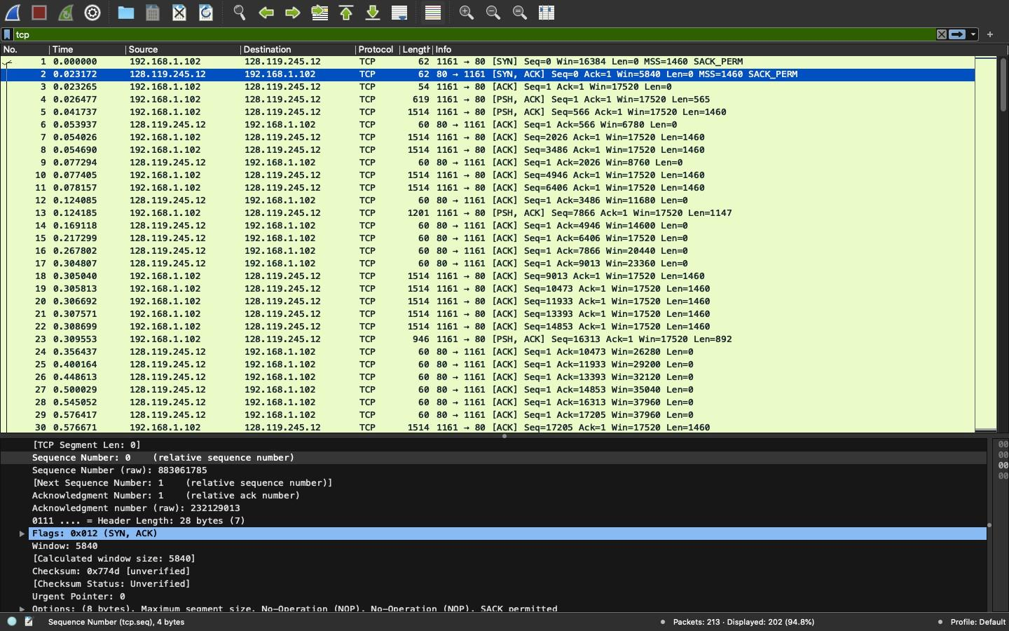

The sequence number of segments containing http post command is 1

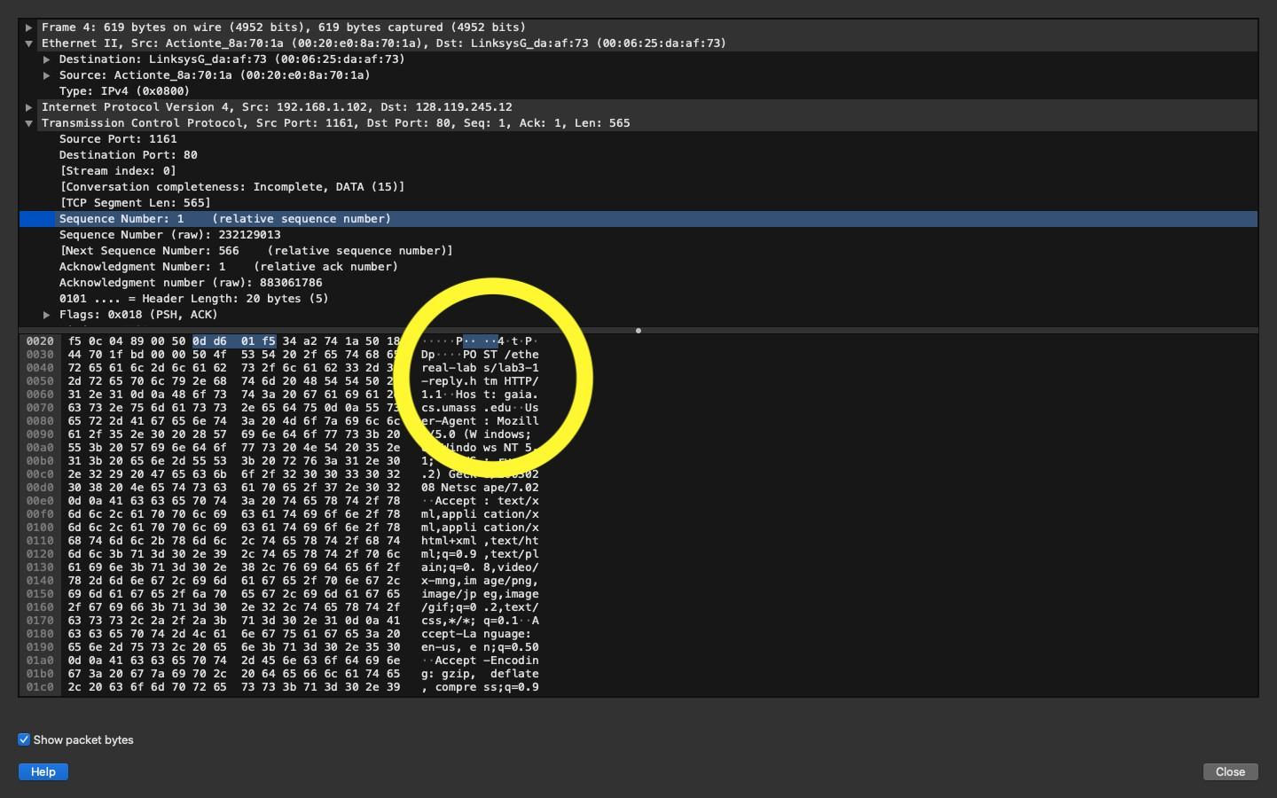

***6.3.6 Sequence number estimated time:***

The http segment is considered the first segment and the segment 1-6 are numbered 4,5,7,8,10,11.

Segment1, sequence number 1

Segment2, sequence number 566

segment 3, sequence number 2026

segment 4, sequence number 3486

segment 5, sequence number 4496

segment 6, sequence number 6406

|  | Airtime(S) | Receive Time(S) | RTT (S) |
| --- | --- | --- | --- |
| segment 1 |  |  |  |
| segment 2 | 0.041737 | 0.053937 | 0.0122 |
| stage 3 | 0.054026 | 0.077294 | 0.023268 |
| segment 4 | 0.054690 | 0.124085 | 0.069395 |
| segment 5 | 0.077405 | 0.169118 | 0.091713 |
| segment 6 | 0.08157 | 0.217299 | 0.139142 |

EstimatedRTT = 0.875 * EstimatedRTT + 0.125 * SampleRTT Estimated RTT after receipt of segment 2 ACK:

Chatter RTT=RTT of Segment2= 0.0122

Estimated RTT after receipt of segment 3 ACK:

Estimated RTT = 0.875 * 0.0122 + 0.125 * 0.023268 = 0.10965S

**Chattered RTT after receiving ACK from segment 4**: Estimated RTT = 0.875 * 0.10965 + 0.125 *0.069395 = 0.1046S

Estimated RTT after receipt of segment 5 ACK:

Estimated RTT = 0.875 * 0.1046 + 0.125 *0.091713 = 0.10298S

Estimated RTT after receipt of segment 6 ACK:

Estimated RTT = 0.875 * 0.10298 + 0.125 *0.139142 = 0.10750S

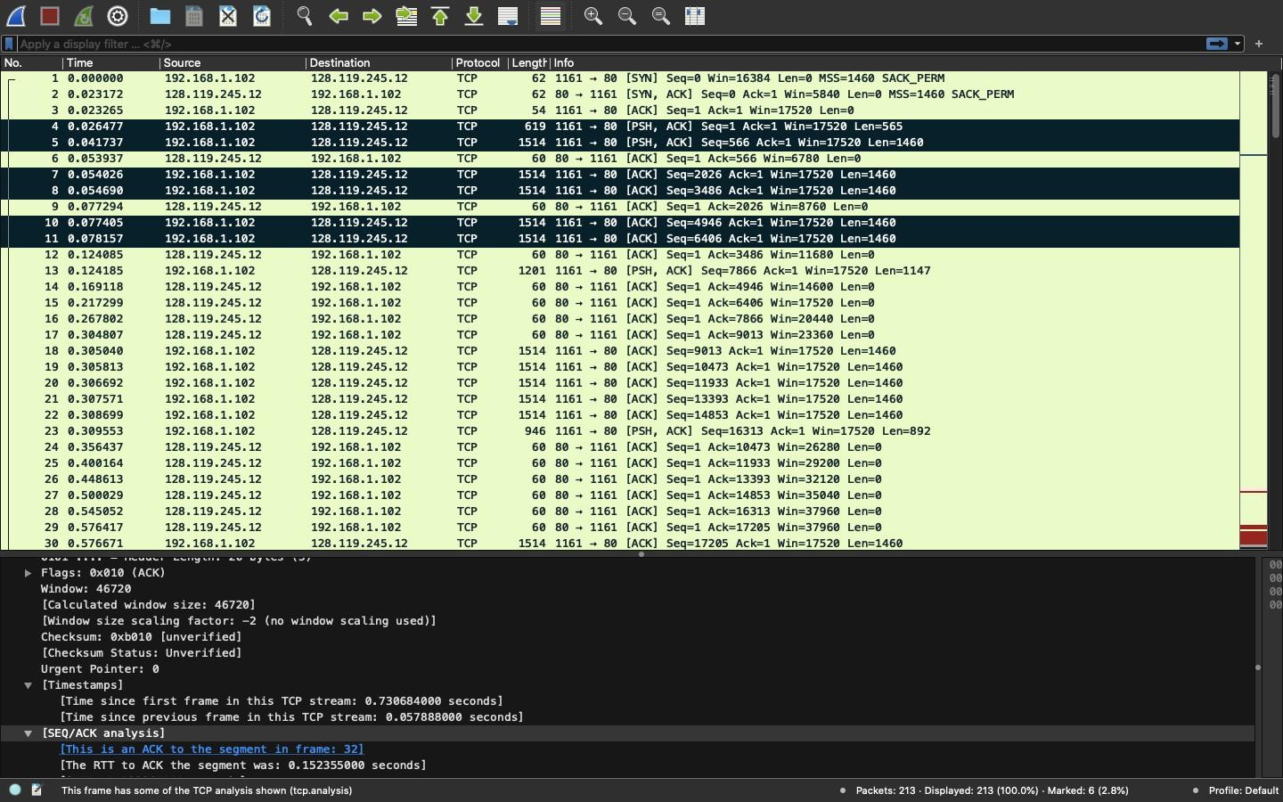

*Figure 6.3 6 Segment 1-6*

***6.3.7 ACK of first 6 segments:***

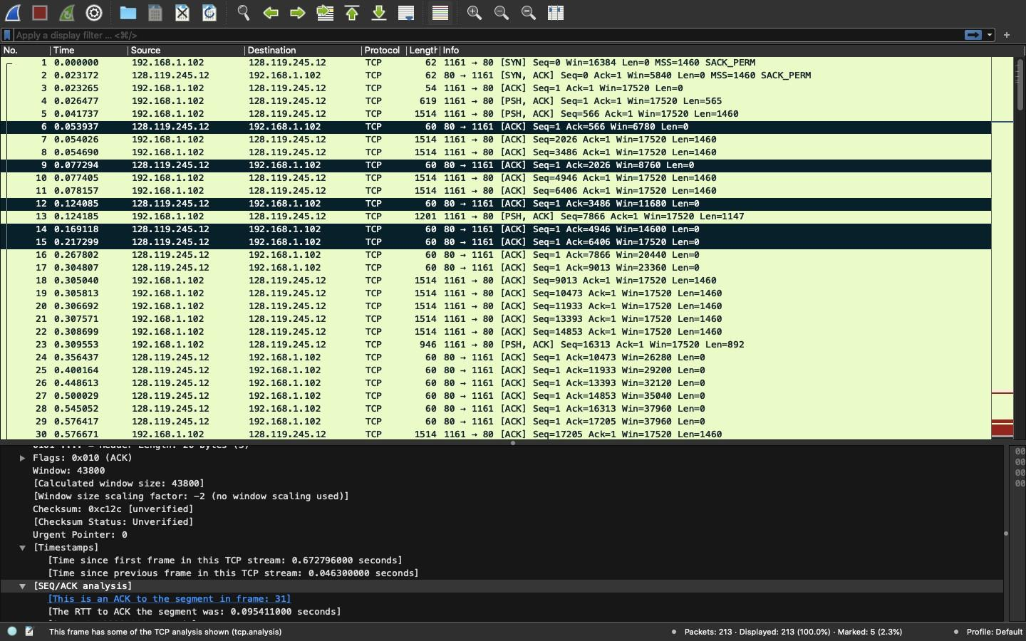

This figure shows the ack of first six segments.

***6.3.8 Road time trip and Length of each segment:***

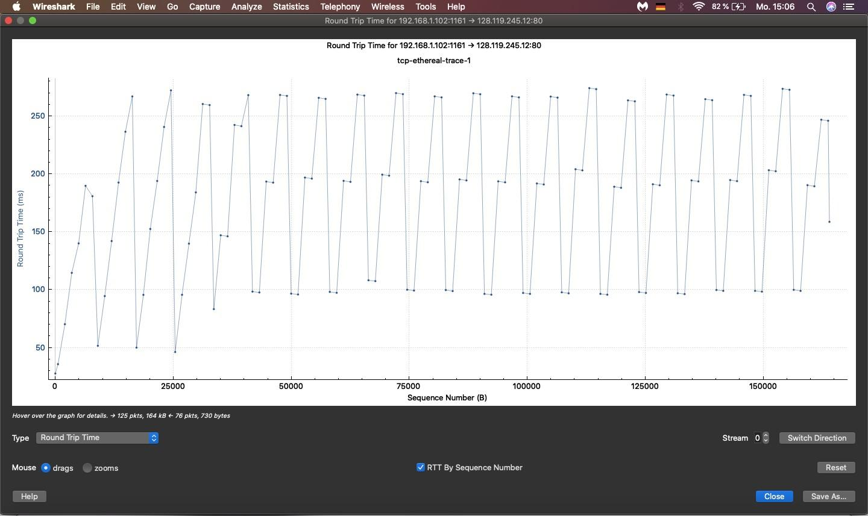

*Figure 6.3 8 Round trip graph*

Figure shows the road trip time from relevant IP.

The length of segments are as follows:

The length of the first six segments

Segment 1: 619 bytes

Segment2: 1514 bytes

Segment 3: 1514 bytes

Segment 4: 1514 bytes

Segment 5: 1414 bytes

Segment 6: 1514 bytes

***6.3.9 Minimal Reception window:***

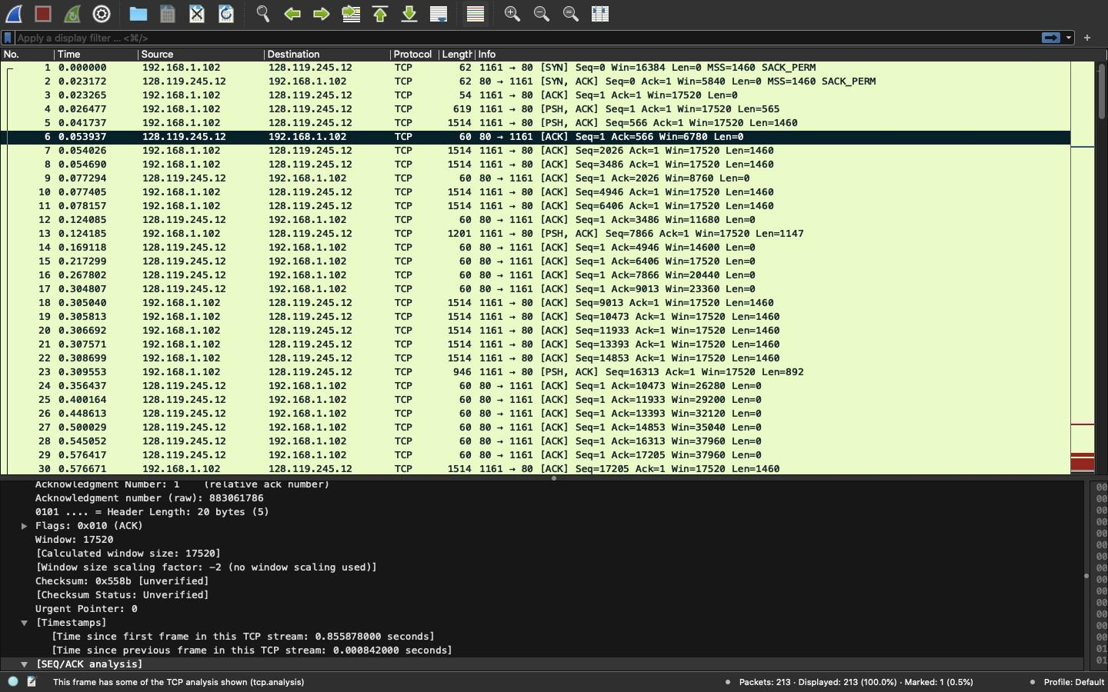

*Figure 6.3 9 minimal reception window (packet 6)*

The minimum amount of disk space available is 6780 bytes. no the lack of buffer space does not throttle the receiver, because we can observe that the buffer keeps growing.

***6.3.10 Stevenson Graph time:***

There is no retransmitted segment in the trace file. We can check it with the Time Sequence Graph. we observe that the Sequence number of each trace from source (192.168.1.102) to destination (128.119.245.12) monotonically increases with time.

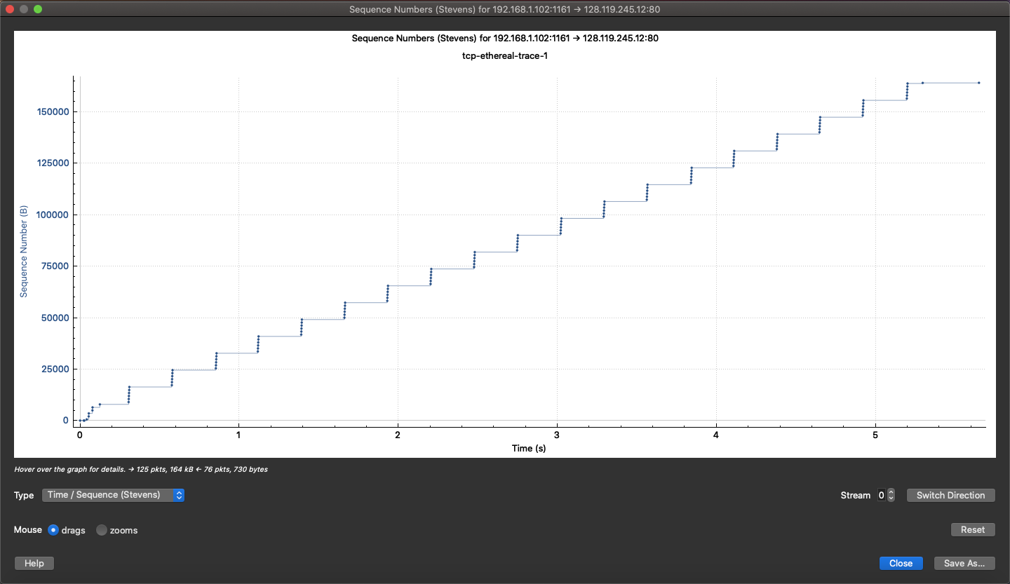

***7. Raspberry Pi Custom Web-server Implementation:***

In this part of the document we have implemented our own custom created web server to find out whether which one of two servers being tested is valid or not.

***7.1 Pre-requisites:***

This implementation like our previous one requires a certain number of pre-requisites which are listed as follows:

**Hardware requirements:**

* Raspbian/Raspberry Pi Micro Chip Operating system (2,3,4)
* Mouse
* Keyboard
* Screen board
* Micro SD card
* Card Reader
* Power Cable over 2.5A for Raspberry Pi

**Virtual requirements:**

* Internet connection.
* Raspbian/Raspberry Pi functioning terminal.
* Relevant Web pages and file.
* Thony Python IDE (in built Raspberry Pi)
* Wireshark

***7.2 Loading Raspberry Pi OS:***

In this part we load and make our Raspberry Pi functional for use.

***7.2.1 Writing Raspberry Pi OS on SD card:***

First step is to load Raspberry Pi OS into our micro SD card to be mounted on the Raspberry Pi to be used the memory processor for the Raspberry Pi.

* Step 1 is to mount the SD card on the card reader and plug it into your personal computer used in the previous implementation.
* Step 2 is to download the Raspberry Pi imager from https://www.raspberrypi.com/software/ for your PC OS, and write the Raspberry Pi OS onto the card.

The writing software should look something like this,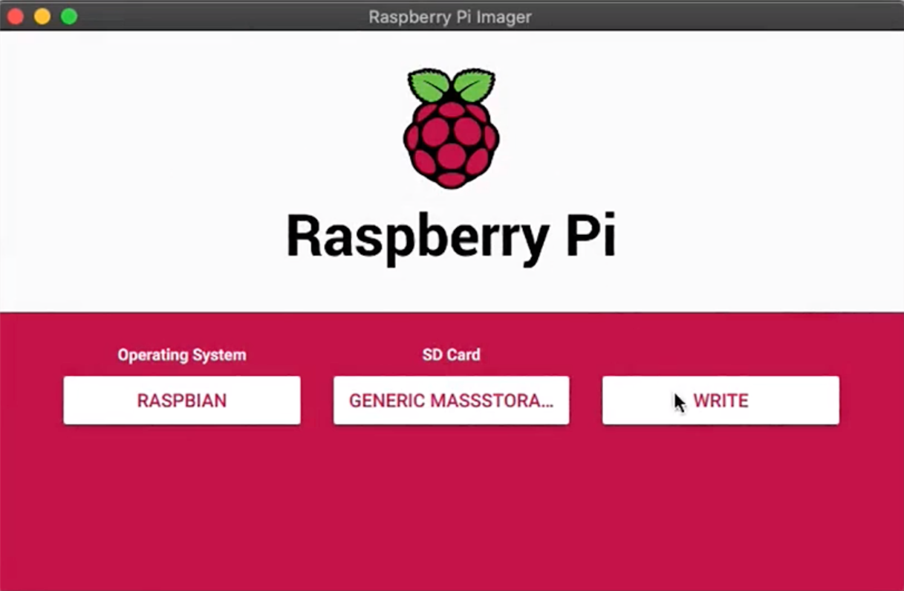

***7.2.2 Connecting your Raspberry Pi:***

In this step you are to connect your mouse, keyboard, Monitor, SD card and Power cable to your Raspberry Pi. Boot up the OS, after booting up follow the instructions on the screen to set up your OS and connect to a standing internet connection.

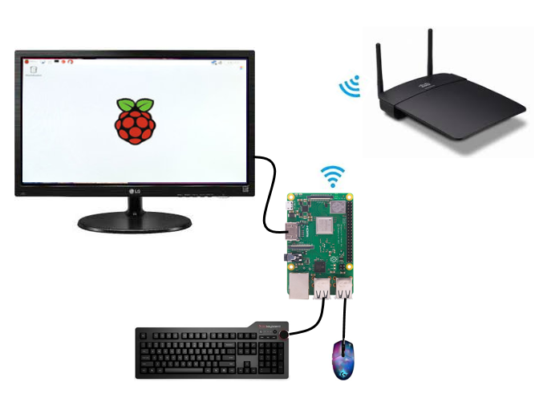

*7.2 2 Raspberry Pi System connected and online*

Once you have followed the steps correctly your setup, should look something like this.

***7.3 Basic Script Programming:***

To implement our programming of a web-server we must first implement some basic Raspberry Pi commands into its terminal, the terminal is accessible from the upper left corner in the Raspberry Pi.

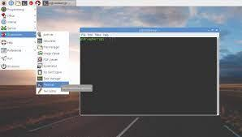

*7.2 3 Raspberry Pi command terminal*

***7.3.1 Basic Web-server script:***

Run the following commands in your terminal before programming your web-server in python, make sure your internet connection is stable.

* sudo apt-get update
* sudo apt-get upgrade
* reboot
* sudo apt install apache2 -y

This will turn your Raspberry Pi into a physical device capable of hosting a web-server. It will use apache for this purpose. Note that sudo apt-get update and upgrade commands might take some time to complete depending upon the speed of your internet connection.

***7.3.2 Wireshark Installation:***

Open a new terminal window, and run the following script to set up your Wireshark.

* sudo apt-get update && sudo apt-get upgrade -y
* sudo apt-get install wireshark
* sudo groupadd wireshark
* sudo usermod -a -G wireshark pi
* sudo chgrp wireshark /usr/bin/dumpcap
* sudo chmod 750 /usr/bin/dumpcap
* ls -al /usr/bin/dumpcap
* sudo setcap cap_net_raw,cap_net_admin=eip /usr/bin/dumpcap
* sudo getcap /usr/bin/dumpcap
* wireshark

The final command “wireshark” will allow for running of wireshark whenever you please, note that whichever terminal will run this command must remain open till you are using wireshark.

***7.4 Python Web-server Script Programming:***

In this part, run the following scripts in different python files to create your web-server and client-server side.

***7.4.1 Python Web-server script:***

from flask import Flask, render_template

app = Flask(__name__)

@app.route('/')

def hello():

return render_template('index.html')

if __name__ == '__main__':

app.run(host='0.0.0.0', port=5000)

To check whether your web-server is functional and loading your html file in the relevant directory, type localhost: 5000 in your browser and it will show you the html page you saved to that web server.

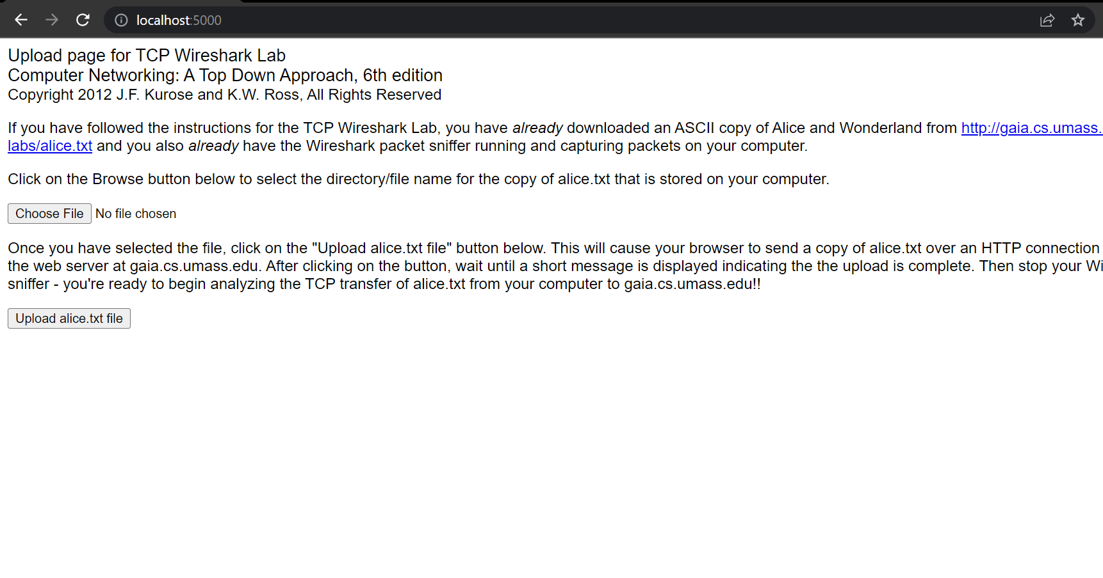

*7.4 1 Web server programming and loading index.html*

With this your web server is fully functional and running. However, the Host IP of the web server is assigned based on whatever WIFI you connect to. To check the Host IP of your web server run the following command in your terminal and it will give you the host IP.

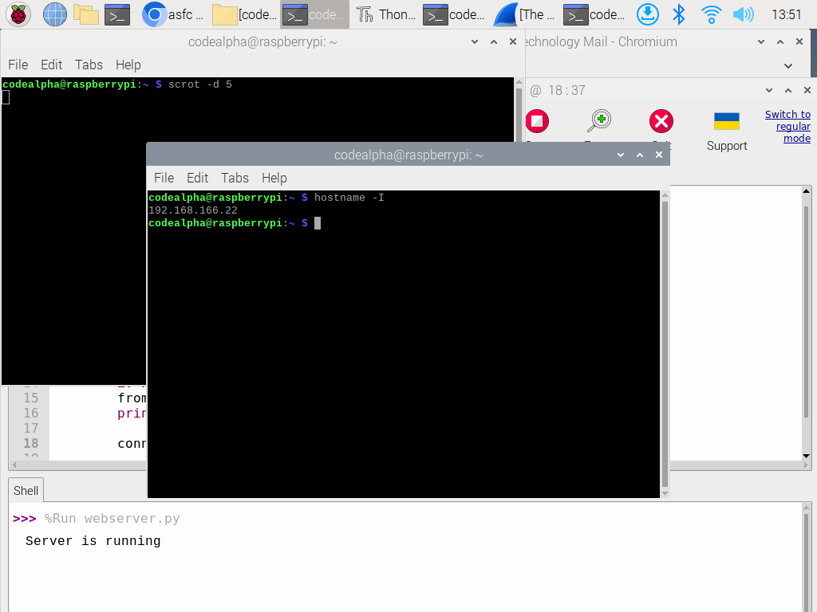

*7.4 3 Host IP assigned after connecting to a relevant Wi-fi or wlan depending on your Raspberry Pi*

That is the main IP address where all your hosting is being kept and your packets will also transfer from that IP.

***7.4.2 Client-side server programming:***

Run the following scripts to program your client side,

*Client server code:*

import socket

# create a socket object

serversocket = socket.socket(socket.AF_INET, socket.SOCK_STREAM)

# get local machine name

host = socket.gethostname()

port = 9999

# bind to the port

serversocket.bind((host, port))

# queue up to 5 requests

serversocket.listen(5)

while True:

# establish a connection

clientsocket,addr = serversocket.accept()

print("Got a connection from %s" % str(addr))

msg = 'Thank you for connecting'+ "\r\n"

clientsocket.send(msg.encode('ascii'))

clientsocket.close()

*Client-side code:*

import socket

# create a socket object

clientsocket = socket.socket(socket.AF_INET, socket.SOCK_STREAM)

# get local machine name

host = socket.gethostname()

port = 9999

# connection to hostname on the port.

clientsocket.connect((host, port))

# Receive no more than 1024 bytes

msg = clientsocket.recv(1024)

clientsocket.close()

print (msg.decode('ascii'))

Once the files have run and loaded into it, your client side will be up and running.

***7.5 Implementation for packet capturing:***

1. Open your browser and retrieve a copy of alice.txt from <http://gaia.cs.umass.edu/wiresharklabs/alice.txt>
2. Open raspberry terminal sudo chown pi:index.html to gain access to index.html file for apache web server. Load the html code from the following file. <http://gaia.cs.umass.edu/wireshark-labs/TCP-wireshark-file1.html>
3. Open your web server using the IP address you have found on your server.

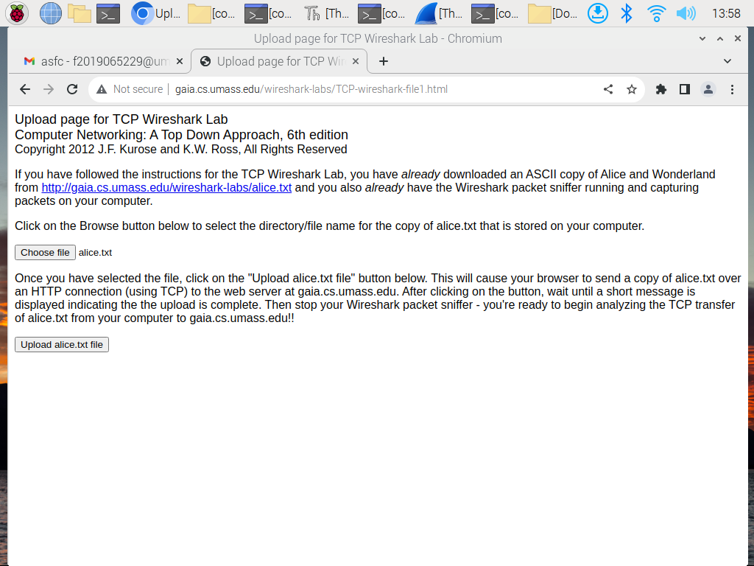

*Figure 7.5 1 Gaia.cs web page loaded on to custom server on Raspberry Pi*

1. Use the browse button on the form to locate and select the file containing "Alice in Wonderland" on your computer. Do not press the "Upload alice.txt file" button yet.

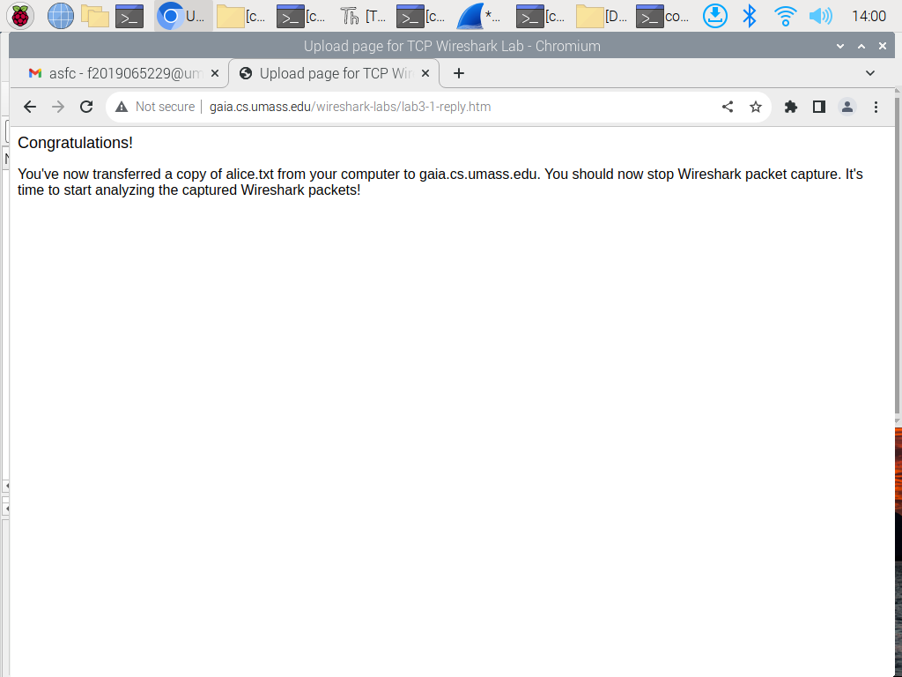

*Figure 7.5 2 Uploading Alice.txt in your broswer*

1. Open Wireshark and start packet capture by going to Capture > Options, then press OK on the Wireshark Packet Capture Options screen.
2. In your browser, press the "Upload alice.txt file" button to upload the file to the gaia.cs.umass.edu server. A message will appear in your browser window once the file has been successfully uploaded.
3. Stop the Wireshark packet capture

The Screen should look like this,

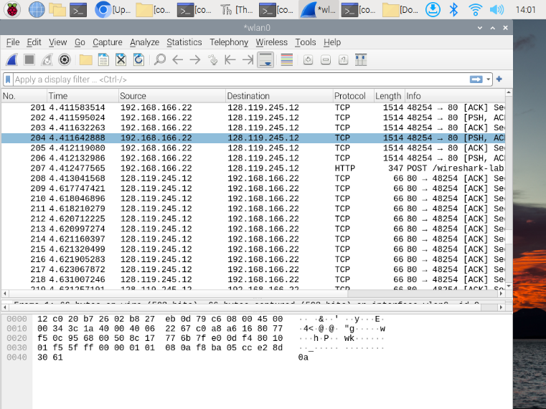

*Figure 7.5 3 Packet Capturing in Raspberry Pi Wireshark*

Now we analyze these packets in a similar way to section 6.

***7.6 Packet Analysis:***

In this section we analyze the packets for our custom created raspberry Pi web server.

***7.6.1 Identifying Source port:***

1. The IP and TCP port number being used by client computer. (source)

Host IP: 192168.166.22

TCP port number: 38248

- The IP and TCP port number being used by gaia.cs.umass.edu

Host IP: 128.119.245.12

TCP port number: 80

- The IP and Port number being used by my own client-computer to gaia.cs.umass.edu

Host IP: 142.250.181.163

TCP port number: 48323

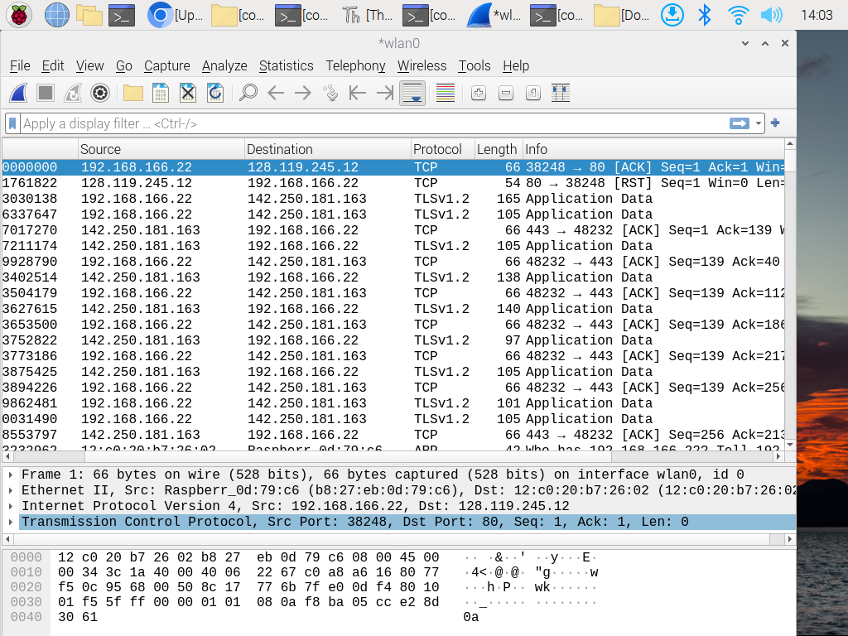

*Figure 7.6 1 IP addresses and TCP port numbers of the client computer (source) and gaia.cs.umass.edu*

In this the grey highlighted text shows the source port from where the packet was sent.

***7.6.2 TCP port and IP addresses from client trace:***

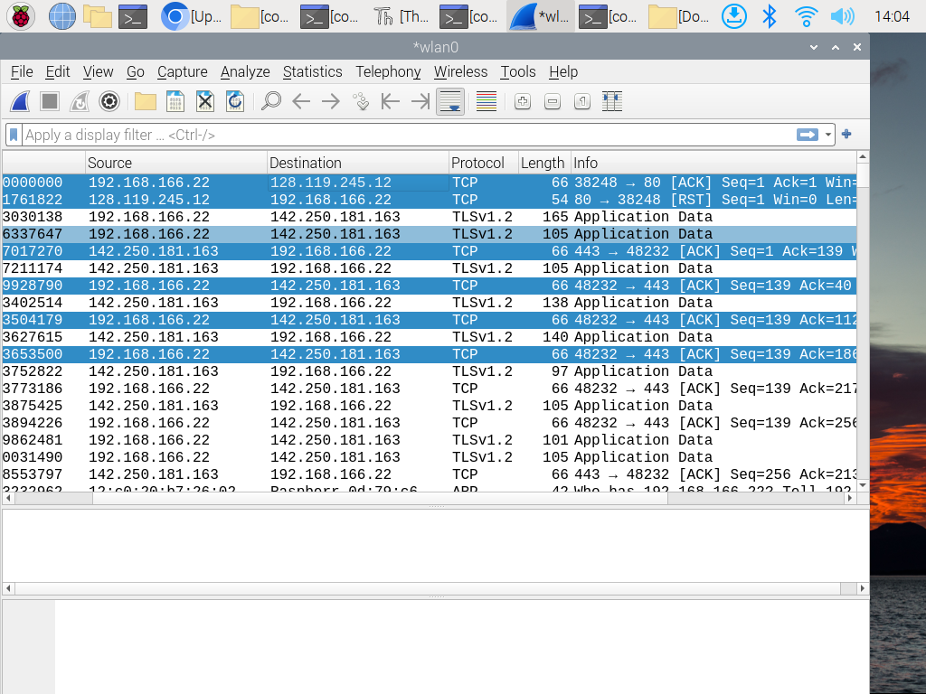

*Figure 7.6 2 IP address and TCP port numbers from my own trace*

This figure shows us TCP port numbers as well as IP addresses that are being issued or communicated from our own trace.

***7.6.3 Syn connection to the server:***

The sequence number of the TCP SYN segment used to establish a TCP connection between the client computer(source) and gaia.cs.umass.edu is 0. In order for the SYN segment to be identified, SYN=1

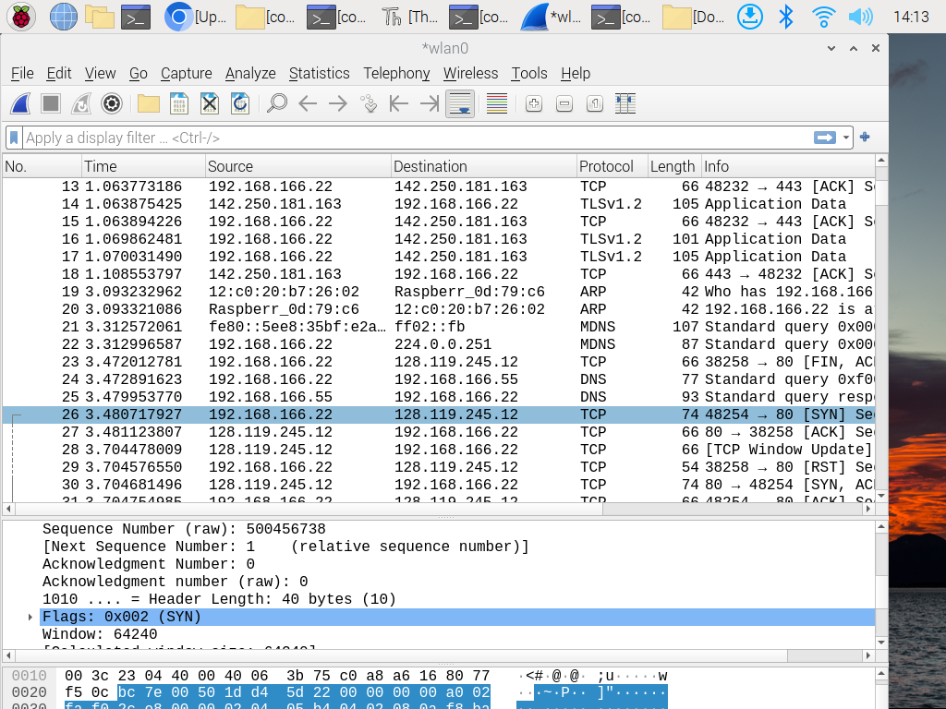

*Figure 7.6 3 Sequence number of the TCP SYN segment*

***7.6.4 SynACK sequence number verification:***

The sequence number of the SYNACK segment returned from gaia.cs.umass.edu

on the client computer the value is 0. The value of the confirmation field in the SYNACK segment is 1. To determine this value, 1 is added to the initial value of the sequence number. and in our case the sequence number is =1. to identify that a segment is a SYNACK segment, the SYN index and the ACK index in the segment are set to 1 law, and indicate that this segment is a SYNACK segment.



*Figure 7.6 4 Sequence number and acknowledgment number of the SYNACK segment*

***7.6.5 Sequence number:***

The sequence number of segments containing http post command is 1

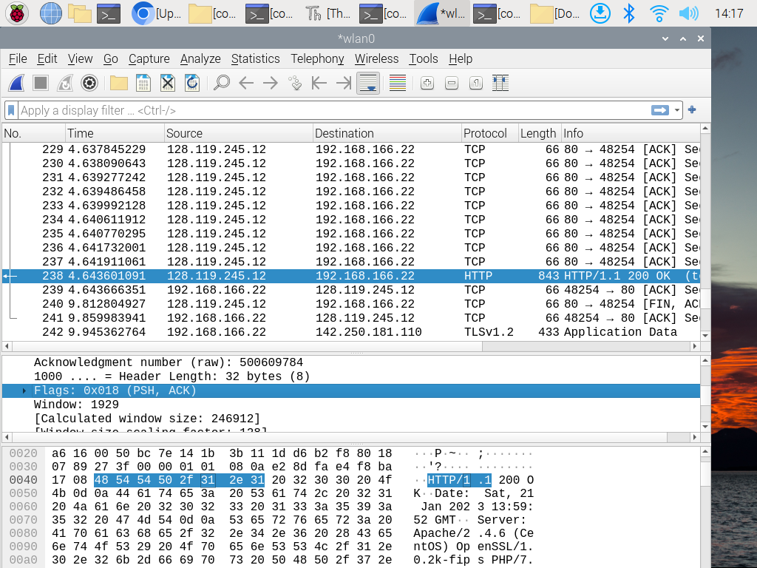

*Figure 7.6 5 Sequence number of the TCP segment containing the HTTP post command*

***7.6.6 ACK of first 6 segments:***

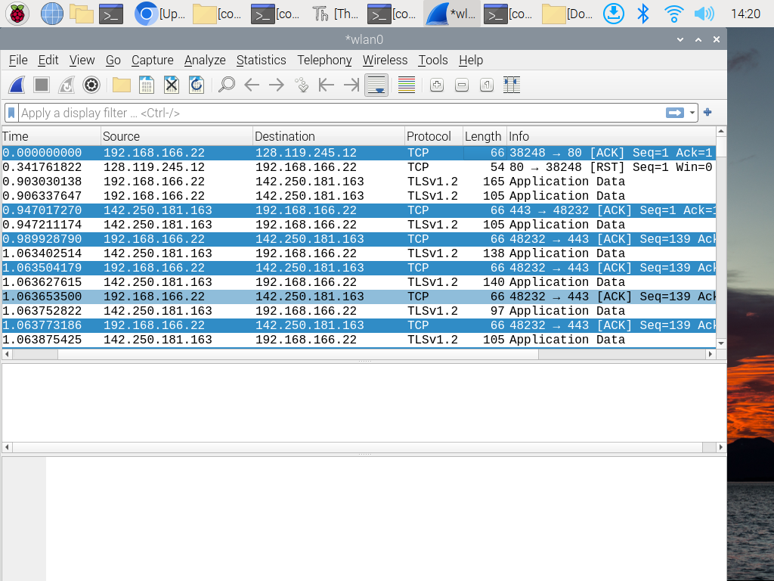

*Figure 7.6 6 ACK of segment 1-6*

This figure shows the ack of first six segments.

***7.6.7 Road time trip and Length of each segment:***

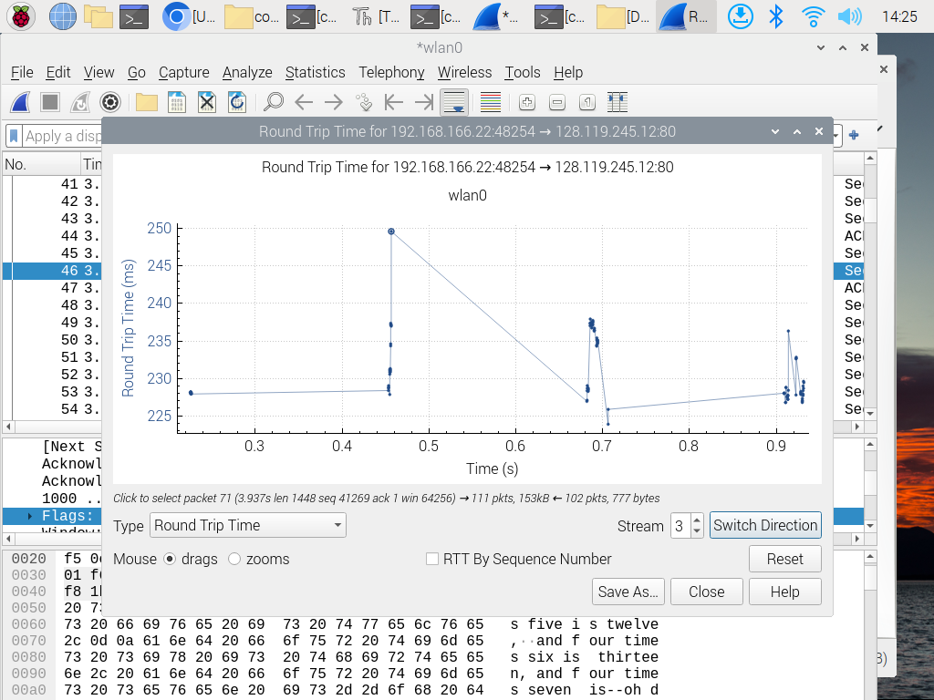

*Figure 7.6 7 Round trip graph Custom server*

Packets are being transferred at a higher rate than a Global Server.

***7.6.8 Minimal Reception window:***

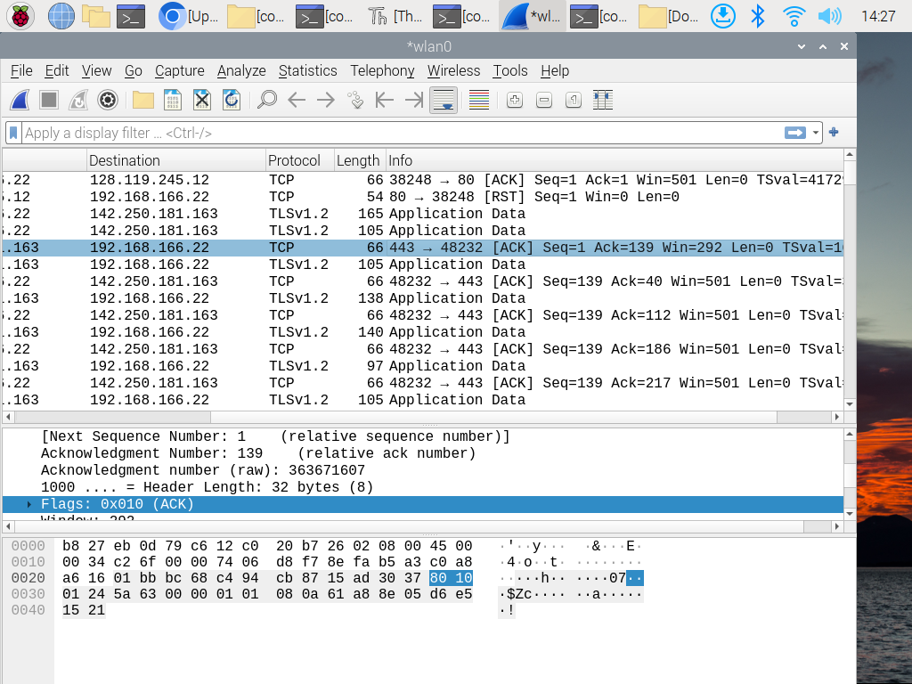

*Figure 7.6 8 minimal reception window (packet 5)*

The minimum amount of disk space available is 6780 bytes header length is 32 bytes. no the lack of buffer space does not throttle the receiver, because we can observe that the buffer keeps growing.

***7.6.9 Stevenson Graph time:***

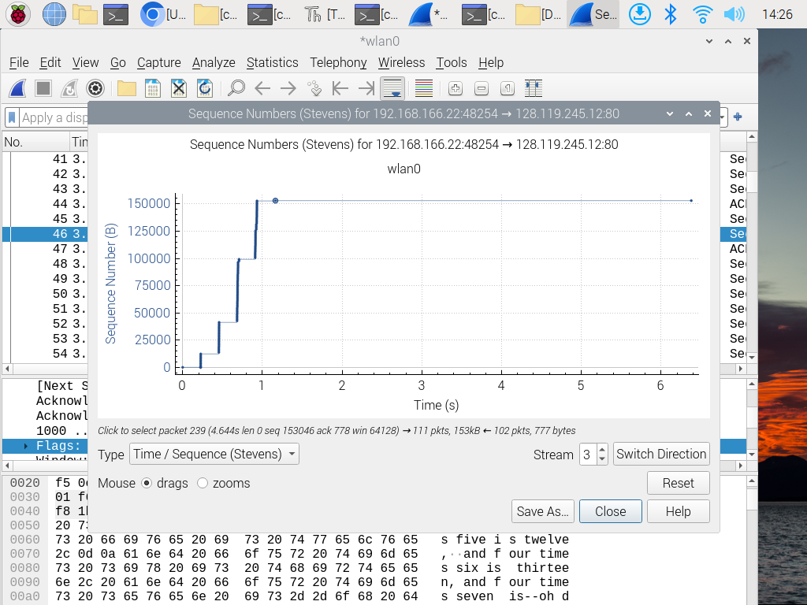

*Figure 7.6 9 Stevenson Graph for custom server*

There is no retransmitted segment in the trace file. We can check it with the Time Sequence Graph. we observe that the Sequence number of each trace from source (192.168.166.22) to destination (128.119.245.12) monotonically increases with time. Packets are delivered at a faster rate than a global server.

***8. Conclusion:***

By matching results from section 6 and section 7 of the thesis, we see similar functionalities being performed by both the global server as well as, our custom created Raspberry Pi web server. The information that is alice.txt is being sent and received in both implementation from <http://gaia.cs.umass.edu/wireshark-labs/TCP-wireshark-file1.html> with relevant IP and TCP port numbers from our own custom created Raspberry Pi server as well. Packet Capturing done in section 6.2 and 7.6 show that, packets from both global and custom created web-server are indeed performing the same way, showing a successful creation of our custom created Raspberry Pi web server.

Comparison between section 6.3.8 and 7.6.7 show that packets sent and received form a custom created web server travel faster than that on the global web server. Similarly we can see that in section 6.3.10 and 7.6.9 the graph ended quicker in the custom server implementation, this is due to the fact all the packets were sent and received at a faster ate than the global server.

Thus, a conclusion is reached that custom created raspberry Pi web servers are indeed able to function the same way as globally created web servers and thus verifies our problem statement. To further modify, the custom created web servers will function faster than globally deployed web servers as they are taking less load than a global web server.

***9. References:***

1. Tanenbaum, A.S., & Wetherall, D.J. (2010). Computer Networks (5th ed.). Prentice Hall.
2. Kurose, J.F., & Ross, K.W. (2017). Computer Networking: A Top-Down Approach (7th ed.). Pearson.
3. Forouzan, B.A. (2015). Data Communications and Networking (5th ed.). McGraw-Hill Education.
4. Comer, D. (2018). Computer Networks and Internets (6th ed.). Pearson.
5. Stallings, W. (2018). Data and Computer Communications (10th ed.). Pearson.
6. Postel, J. (1981). Internet Protocol. RFC 791.
7. Cerf, V., & Kahn, R. (1974). A Protocol for Packet Network Intercommunication. IEEE Transactions on Communications, 22(5), 637-648.
8. Peterson, L.L., & Davie, B.S. (2017). Computer Networks: A Systems Approach (6th ed.). Morgan Kaufmann Publishers.
9. Tanenbaum, A.S. (2016). Computer Networks (5th ed.). Pearson.
10. D.E. Comer, Internetworking with TCP/IP, Vol.1: Principles, Protocols, and Architecture, Prentice Hall, Englewood Cliffs, NJ, 1991.
11. R. Perlman, Interconnections: Bridges, Routers, Switches, and Internetworking Protocols, Addison-Wesley, Reading, MA, 1999.
12. W. Stallings, Wireless Communications and Networks, Prentice Hall, Upper Saddle River, NJ, 2002.
13. T. S. Eugene, An Introduction to Computer Networks, Cambridge University Press, Cambridge, UK, 2012.
14. J. F. Kurose and K. W. Ross, Computer Networking: A Top-Down Approach, 7th edition, Pearson, Boston, 2017.
15. C. S. Raghavendra, K. K. Ramakrishnan, and J. J. Garcia-Luna-Aceves, An Introduction to Computer Networks, Cambridge University Press, Cambridge, UK, 2008.